

REACT WITH TYPESCRIPT

Everything from A to Z

by Mayya Markova

# Content

Introduction 5

Checklist 5

Variables 5

Functions 5

Objects 6

Arrays 6

Asynchronous code 7

Document Object Model (DOM) 7

TypeScript 7

Initial Setup 8

Node 8

Package manager 8

Code editor 9

React Overview 9

React Setup 10

Create React App 10

Setup from scratch 14

JSX 15

React Components 16

Props 18

*children* prop 19

*key* prop 20

Rendering lists 20

Conditional Rendering 22

With *If* statement 22

With logical AND *&&* 22

With ternary operator *() ? () : ()* 23

Adding Styles 23

Inline styles 24

Plain CSS 25

CSS modules 26

UI components libraires 28

Hooks Overview 29

*useId* hook 30

State & *useState* hook 31

State 31

*useState* 31

Batching state updates 32

React 17 and prior 33

React 18 34

Lifecycle & *useEffect* hook 35

Components lifecycle 35

*useEffect* 35

Effect callback 36

Cleanup function 38

Dependency array 40

*useLayoutEffect* hook 40

*useReducer* hook 42

Initial state 43

Initializer function 43

Reducer function 43

Action object 44

Dispatch function 45

Context & *useContext* hook 50

Create the context 52

Wrap the component into a context provider 53

Consume the context with *useContext* 53

Refs, *useRef* & *useImperativeHandle* hooks 55

*useRef* 55

Ref forwarding 56

*useImperativeHandle* 57

Memoizations 59

*React.memo()* 59

*useMemo* 61

*useCallback* 61

*useTransition* hook 63

Debounce, throttle & *useDeferredValue* hook 66

Debounce and throttle 66

*useDeferredValue* 68

Custom Hooks 70

Suspense & Error boundaries 74

Suspense 76

Handle loading 76

Lazy loading 79

Error Boundary 81

Handling Forms in react 85

Controlled and Uncontrolled components 85

Controlled component 86

Basic controlled form 86

Controlled form with validations 89

Dynamically-rendered controlled form 90

Uncontrolled component 90

Basic uncontrolled form 90

Uncontrolled form with validations 91

React Hook Froms 94

Formik 98

Routing in React 100

React Router DOM 100

Next.js 105

An example of a small project 114

Build your own project 120

Weather App 120

Cookbook App 120

Movies App 120

E-commerce App 120

Social Media App 121

Quiz App 121

Job Board App 121

# Introduction

This is the ultimate React 18 with TypeScript training path. If you have never touched React before, don’t worry – we are going to cover everything here, from A to Z. If you have some experience, this path can also be interesting for you – it includes advanced topics and latest React features (Oct 2023).

There are a lot of topics here, but as you can see each title is colored in blue, green or red. This color matches the difficulty of the topic – **blue is for** **basics**; **green is for** **intermediate**; and **red is for** **advanced**.

All code examples could be found in [this](https://github.com/mayyamark/react-training-path) git repository.

Now let’s move to the next section – **Checklist**.

# Checklist

Before we start learning React, you must have a good knowledge of JavaScript and HTML5, understanding CSS would be helpful as well. Here is a list of things that you should feel comfortable with:

## Variables

We use [variables](https://developer.mozilla.org/en-US/docs/Learn/JavaScript/First_steps/Variables) to store information. In JavaScript we can define them with *var*, *let* or *const*. In this training we are going to use *const* almost everywhere and *let* – once or twice.

## Functions

We are going to write functional code, so [functions](https://developer.mozilla.org/en-US/docs/Web/JavaScript/Reference/Functions) are essential for us. There are function declarations, function expressions and arrow functions. We are going to use [arrow functions](https://developer.mozilla.org/en-US/docs/Web/JavaScript/Reference/Functions/Arrow_functions) everywhere in this training. Remember, functions are first-class citizens in JavaScript, so doing things like passing a function as an argument is something normal. [Default parameters](https://developer.mozilla.org/en-US/docs/Web/JavaScript/Reference/Functions/Default_parameters) and [rest parameters](https://developer.mozilla.org/en-US/docs/Web/JavaScript/Reference/Functions/rest_parameters) are things, that we are often going to use.

## Objects

[Objects](https://developer.mozilla.org/en-US/docs/Web/JavaScript/Reference/Global_Objects/Object) are key-value pairs, where the keys should be unique. Usually, we create objects, using object literals. A common practice is to “unpack” values from objects, using [destructuring](https://developer.mozilla.org/en-US/docs/Web/JavaScript/Reference/Operators/Destructuring_assignment).

In React mutations are forbidden, so it is important for you to know how to [make copies](https://www.javascripttutorial.net/object/3-ways-to-copy-objects-in-javascript/). Creating a deep copy is an expensive operation and it’s an overkill for our purposes, so shallow copies are good enough. The most famous way to make a shallow copy is with the [spread operator](https://developer.mozilla.org/en-US/docs/Web/JavaScript/Reference/Operators/Spread_syntax).

## Arrays

An [array](https://developer.mozilla.org/en-US/docs/Web/JavaScript/Reference/Global_Objects/Array) is a sorted collection of elements. We are not going to use loops to iterate over arrays, but some of the build-in methods. We can divide them in two categories:

* **Non-mutators** – don’t mutate the original array.
  + [*Array.map()*](https://developer.mozilla.org/en-US/docs/Web/JavaScript/Reference/Global_Objects/Array/map) – Accepts a function, that is being called for each element in the array. As a result, we receive a new array.
  + [*Array.filter()*](https://developer.mozilla.org/en-US/docs/Web/JavaScript/Reference/Global_Objects/Array/filter) – Accepts a predicate function. The result is a new array with all elements, that pass the “test”.
  + [*Array.reduce()*](https://developer.mozilla.org/en-US/docs/Web/JavaScript/Reference/Global_Objects/Array/reduce) – Executes a reducer function for each element and returns the accumulated result.
  + [*Array.slice()*](https://developer.mozilla.org/en-US/docs/Web/JavaScript/Reference/Global_Objects/Array/slice) – Returns selected elements from the array.
  + [*Array.findIndex()*](https://developer.mozilla.org/en-US/docs/Web/JavaScript/Reference/Global_Objects/Array/findIndex) – Returns the index of the first element, that satisfies the provided “test”.
* **Mutators** – mutate the original array.
  + [*Array.splice()*](https://developer.mozilla.org/en-US/docs/Web/JavaScript/Reference/Global_Objects/Array/splice) – This method adds and/or removes array elements.

Like objects, we are going to make shallow copies here as well. Mostly we are going to accomplish that with the [spread operator](https://developer.mozilla.org/en-US/docs/Web/JavaScript/Reference/Operators/Spread_syntax), [*Array.slice()*](https://developer.mozilla.org/en-US/docs/Web/JavaScript/Reference/Global_Objects/Array/slice) (without specifying indexes, the method returns a shallow copy of the array), [*Array.filter()*](https://developer.mozilla.org/en-US/docs/Web/JavaScript/Reference/Global_Objects/Array/filter) (it returns a new array) or [*Array.reduce()*](https://developer.mozilla.org/en-US/docs/Web/JavaScript/Reference/Global_Objects/Array/reduce) (we pass an empty array as initial value of the accumulator).

[Destructuring](https://developer.mozilla.org/en-US/docs/Web/JavaScript/Reference/Operators/Destructuring_assignment) is also important here.

## Asynchronous code

It’s interesting that JavaScript is single-threaded, but the [event loop](https://developer.mozilla.org/en-US/docs/Web/JavaScript/Event_loop) concept gives us the illusion of multi-threading. Make sure you understand how the JavaScript engine works. [Promises](https://developer.mozilla.org/en-US/docs/Web/JavaScript/Reference/Global_Objects/Promise) are the foundation of [asynchronous programming](https://developer.mozilla.org/en-US/docs/Learn/JavaScript/Asynchronous) in modern JavaScript. A promise is an object, returned by an asynchronous function, which represents the current state of the operation. For this training you need to be familiar with the [fetch API](https://developer.mozilla.org/en-US/docs/Web/API/Fetch_API), [chained promises](https://developer.mozilla.org/en-US/docs/Web/JavaScript/Reference/Global_Objects/Promise#chained_promises), the [*async*](https://developer.mozilla.org/en-US/docs/Web/JavaScript/Reference/Statements/async_function) & [*await*](https://developer.mozilla.org/en-US/docs/Web/JavaScript/Reference/Operators/await) syntax (this is just a syntactic sugar over promises) and catching errors with [*Promise.catch()*](https://developer.mozilla.org/en-US/docs/Web/JavaScript/Reference/Global_Objects/Promise/catch) or with [*try/catch statement*](https://developer.mozilla.org/en-US/docs/Web/JavaScript/Reference/Statements/try...catch).

## Document Object Model (DOM)

The [Document Object Model](https://developer.mozilla.org/en-US/docs/Web/API/Document_Object_Model) is an API that represents and interacts with HTML or XML documents. With this API JavaScript can access, change, add or remove HTML elements (and their attributes) in the page.

## TypeScript

Last, but not least, having some basic [TypeScript](https://www.typescriptlang.org/) knowledge would be great. Basically, it’s JavaScript with added syntax for types. Don’t worry if you have no idea what it is – it’s something that’s super easy to learn. All you need to know for now is:

* [There is type inference](https://www.typescriptlang.org/docs/handbook/typescript-in-5-minutes.html#types-by-inference) – It’s not necessary to annotate types always. When the type is not explicitly declared by the user, TypeScript will use the value of the variable as a type.
* [Describe an array](https://www.typescriptlang.org/docs/handbook/2/everyday-types.html#arrays)
* [Describe a function](https://www.typescriptlang.org/docs/handbook/2/everyday-types.html#functions)
* Describe an object – We can do this [inline](https://www.typescriptlang.org/docs/handbook/2/everyday-types.html#object-types) or by declaring an [interface](https://www.typescriptlang.org/docs/handbook/typescript-tooling-in-5-minutes.html#interfaces). Sometimes we have [optional properties](https://www.typescriptlang.org/docs/handbook/2/everyday-types.html#optional-properties), so there is a special syntax for that.
* [Creating unions](https://www.typescriptlang.org/docs/handbook/typescript-in-5-minutes.html#unions) – this is useful when e.g., you have a variable that is a *null* or an *array*.

# Initial Setup

To start working you need to install a few things on your machine.

## Node

[Node](https://nodejs.org/en) is the JavaScript runtime environment. It allows you to execute JavaScript code outside a web browser. If the installation was successful, the command **node –v**, executed in a terminal, should output the current version. We are going to use 18.16.0.

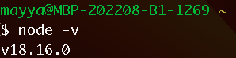

## Package manager

When you install Node, [npm](https://www.npmjs.com/) is installed by default. Npm stands for Node Package Manager. It is a library and a registry for JavaScript software packages. It also has command-line tools to help you install different packages and manage their dependencies. In a terminal, execute **npm –v** to check which is your current version.

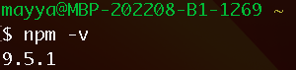

We are going to use the second option - [yarn](https://yarnpkg.com/). Yarn offers faster performance, better security, and offline mode capabilities. Use npm to intall it globally: **npm install --global yarn**.

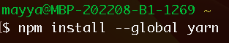

Again, use **yarn -v** to check the current version. We are going to use 1.22.19.

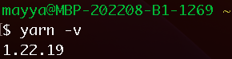

## Code editor

We are going to use [Visual Studio Code](https://code.visualstudio.com/). Here is a list of optional, but very helpful, extensions, that you can install:

* [ESLint](https://marketplace.visualstudio.com/items?itemName=dbaeumer.vscode-eslint) - Integrates [ESLint](https://eslint.org/) into VS Code. This one is important. Every project has lint rules, and this extension tells VSCode if there is a problem in your code.
* [Auto Rename Tag](https://marketplace.visualstudio.com/items?itemName=formulahendry.auto-rename-tag) - Automatically rename paired HTML/XML/JSX tag. Don’t worry for the JSX word, we will explain that in shortly.
* [Colorize](https://marketplace.visualstudio.com/items?itemName=kamikillerto.vscode-colorize) - Instantly visualize CSS colors in your CSS/ SASS/LESS/XML, etc. files.
* [Error lens](https://marketplace.visualstudio.com/items?itemName=usernamehw.errorlens) - Highlights the entire line wherever a diagnostic is generated by the language and prints the message inline.
* [Path Intellisense](https://marketplace.visualstudio.com/items?itemName=christian-kohler.path-intellisense) – Plugin that autocompletes filenames.
* [VSCode Icons](https://marketplace.visualstudio.com/items?itemName=vscode-icons-team.vscode-icons) – Extension, that adds an icon to improve your file’s appearance in the Explorer.

Feel free to use any other code editor.

# React Overview

It’s time to dive into React. React is a declarative, efficient, and flexible JavaScript library for building reusable UI components. It is an open-source, component-based frontend library which is responsible only for the view layer of the application.

Here are some of React’s advantages that made it so popular these days:

* It’s used to create single page applications (SPA): A [SPA](https://developer.mozilla.org/en-US/docs/Glossary/SPA) is a web app implementation that loads only a single web document, and then updates the body content of that single document.
* Performance is improved: React uses [Virtual DOM](https://adhithiravi.medium.com/react-virtual-dom-explained-in-simple-english-fc2d0b277bc5), thereby creating web applications faster. Virtual DOM compares the components’ previous states and updates only the items in the Real DOM that were changed, instead of updating all of the components again, as conventional web applications do.
* Components are reusable: Components are the building blocks of any React application, and a single app usually consists of multiple components. These components have their logic and controls, and they can be reused throughout the application, which in turn dramatically reduces the application’s development time. More on that in the **React Components** section.
* The data flow is unidirectional: This means that when designing a React application, developers often nest child components within parent components. Since the data flows in a single direction, it becomes easier to debug errors and know where a problem occurs in our application.
* Small learning curve: React is easy to learn, as it mostly combines basic HTML and JavaScript concepts with some beneficial additions. Still, as is the case with other tools and frameworks, you need to spend some time to get a proper understanding of React’s library.
* It can be used for the development of both web and mobile apps: We already know that React is used for the development of web applications, but that’s not all it can do. There is a framework called [React Native](https://reactnative.dev/), derived from React itself, that is hugely popular and is used for creating beautiful mobile applications. So, in reality, React can be used for making both web and mobile applications.
* It is supported by a large community.

# React Setup

## Create React App

In this training we are going to use [Create React App](https://create-react-app.dev/). It is an officially supported way to create single-page React applications. It offers a modern build setup with no configuration.

Let’s create one React application with this tool. We are going to use the [TypeScript template](https://create-react-app.dev/docs/adding-typescript/). Open a terminal and execute the following command: **yarn create react-app my-app --template typescript** (or **npx create-react-app my-app --template typescript**). This command has generated a directory *my-app*. Open this directory in VS Code *(demo* [*01-create-react-app*](https://github.com/mayyamark/react-training-path/tree/master/01-create-react-app)*)*. This is the structure we have:

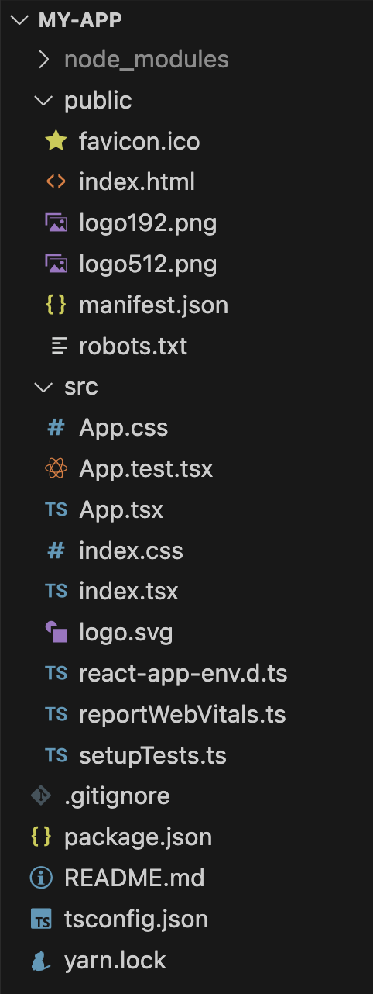

Let’s explain what we have:

* *package.json*  
   This file holds the metadata about the project – name, description, package version, dependencies, etc.

Here we have installed:

* a few [Testing Library](https://testing-library.com/) packages – used for unit tests.
* a few typing packages – used from TypeScript.
* React
* [ReactDOM](https://github.com/facebook/react/tree/main/packages/react-dom) – it is responsible for rendering our components on the web.
* [React Scripts](https://github.com/facebook/create-react-app/tree/main/packages/react-scripts) – a package, created from the Create React App, that contains all scripts for managing the application – starting, building, etc.
* [TypeScript](https://www.typescriptlang.org/) – the package enables us to use TypeScript (*.ts* and *.tsx* files) in our project.
* [Web Vitalis](https://github.com/GoogleChrome/web-vitals#readme) – a package for measuring performance.
* *yarn.lock* (or *package-lock.json*)

A file, that describes the project's dependency graph – direct dependencies, child dependencies, and so on.

* *README.md*  
   This is a file, that contains the repository name and some basic instructions.
* *.gitignore*  
   This is the file, that specifies intentionally untracked files that Git should ignore.
* *node_modules*   
   You can think of the *node_modules* folder like a cache for the external modules that your project depends upon. When you install them, they are downloaded from the web and copied into the *node_modules* folder and Node.js is “trained” to look for them there when you import them (without a specific path). We refer to it as a cache because the *node_modules* folder can be entirely recreated from scratch at any time by just reinstalling all the dependent modules.
* *public* directory

This directory contains the *index.html* file. This file is essential. If you open it, you will notice that in the body tag there is a div with an id root. By convention it is called “root” element, because everything inside it will be managed by the special package ReactDOM. Don’t worry for the installation of this package, if you remember Create React App has already set this up for us.

We should put our assets here as well – images, favicon, [manifest file](https://developer.mozilla.org/en-US/docs/Web/Manifest), fonts, etc. You can find more information [here](https://create-react-app.dev/docs/using-the-public-folder/).

* *src* directory

This is the main directory, where our logic lives – components, helper functions, unit tests, etc.

Did you notice the *index.tsx* file? This is the place, where ReactDOM is configured to find the div with id “root” and to render our main React component inside it. By convention the main component is called *App*. If we have a global CSS file, we can import it here.

*App.tsx* is the file that contains our main component. *App.css* is the file that contains specific styles for the component and *App.test.tsx* is a file, where we can add some unit tests. Yes, Create React App comes with configurations for testing as well (*setupTests.ts* is a file, where we can add custom configurations).

There is also another file here – *reportWebVitalis.ts*. It contains the configuration for the web-vitalis package. This logic is imported in *index.tsx*. You can find more information about the configurations [here](https://create-react-app.dev/docs/measuring-performance/).

This initial structure is great. At some point you will add more and more logic to your application. It is highly recommended to add more folders to organize the project. You can find a few ideas [here](https://blog.webdevsimplified.com/2022-07/react-folder-structure/). If your application is going to be a complex one, with a lot of components, we would suggest to organize the components directory by following the [Atomic design structure](https://bootcamp.uxdesign.cc/atomic-design-structure-41240c455ce6).

There are many other alternatives to Create React App. Check [this article](https://www.robinwieruch.de/react-starter/) to learn more about them.

## Setup from scratch

If you prefer to make the whole setup from scratch, [here is a great guide](https://aglowiditsolutions.com/blog/react-webpack/), that you can follow. Here is a checklist:

* Create a root folder for the project.
* Create a *package.json* file. Use **yarn init** (**npm init**) and follow the instructions to generate one.
* Install React and ReactDOM with **yarn add react react-dom** (or **npm install react react-dom**).
* Setup [Webpack](https://webpack.js.org/). This is a module bundler (manages and loads independent modules). It takes dependent modules and compiles them to a single (file) bundle.
* Use the following command: **yarn add -D webpack webpack-dev-server webpack-cli html-webpack-plugin** (**npm install -D webpack webpack-dev-server webpack-cli html-webpack-plugin**).
* *webpack* – includes all core webpack functionality.
* *webpack-dev-server* – a server, that automatically reruns webpack when files are changed.
* *webpack-cli* – allows running webpack from the command line.
* *html-webpack-plugin* – helps to create a HTML template for your application.
* Create a *webpack-config.js*, where you need to configure it (follow the guide).
* Install [Babel](https://babeljs.io/). This is a JavaScript compiler and transpiler. It converts one source code to other. Using this you will be able to use the new [ES6 features](http://es6-features.org/) in your code where, babel converts it into plain old ES5 which can be run on all browsers.
* Use the following command: **yarn add -D @babel/core @babel/preset-env @babel/preset-react babel-loader** (**npm install -D @babel/core @babel/preset-env @babel/preset-react babel-loader**).
* *@babel/core* – the main engine package for the babel.
* *@babel/preset-env* – adds support to ES5/ES6 JavaScript.
* *@babel/preset-react* – adds support for React JSX code.
* *babel-loader* – transpiles the React JSX code in backward compatible JS code with the help of babel and webpack.
* Update the *webpack-config.js* file to use the packages, we installed (use the guide).
* Setup TypeScript – The guide doesn’t include the TypeScript setup, so check [this article](https://www.codementor.io/@rajjeet/getting-started-with-typescript-4-easy-steps-1do2bnxl6i) and follow the instructions.
* Use the following command: **yarn add -D typescript ts-loader @types/react @types/react-dom**
* Add the TypeScript configuration file – *tsconfig.json* .
* Add more configurations to *webpack.config.js* to start using TypeScript.
* Create the project structure. As a minimum, you need:
* *index.html*, where your single HTML will leave.
* *index.tsx*, where you will configure ReactDOM.
* *App.tsx*, your main component.

# JSX

We are finally ready to start learning. React has a special syntax, called JSX. JSX stands for JavaScript XML. It makes it easier to write HTML and JavaScript together. There are some rules and principles that we need to follow:

* Standard HTML element use lowercase names – *<div>, <form>, <h1>,* …
* Custom React components use Pascal case names – *<MyComponent />,* …
* There should be always a root element
* If you want to group elements without a wrapper node, you can use a special component, called [*React.Fragment (<></>)*](https://react.dev/reference/react/Fragment)*.*
* Write expressions inside curly braces *(demo* [*02-jsx*](https://github.com/mayyamark/react-training-path/tree/master/02-jsx)*)*



Did you notice the third rule? You always need to return a single node. The reason for it is that [Babel](https://babeljs.io/docs/) compiles JSX to JS calls of the [*React.createElement*](https://react.dev/reference/react/createElement) function. Here is an illustration of this:

|  |  |  |
| --- | --- | --- |
|  | Babel |  |

The official documentation for JSX could be found [here](https://react.dev/learn/writing-markup-with-jsx).

# React Components

React components are the building blocks of React. They are independent and reusable pieces of code that display parts of the page.

All react components should start with a capital letter – Header, Footer, etc.

Components use a special object, called *props*, to communicate between each other. See the **Props** section for more details about this special object.

Components come in two types:

* **Functions** – JS functions that accept *props* as an argument and return JSX.
* **Classes (legacy)** – JS classes, which extend [*React.Component*](https://react.dev/reference/react/Component) and return JSX. We won’t cover classes here.

There is another classification of components, that splits them into:

* **Stateful** – Components, that have state. They use the *useState* hook to manage and manipulate their internal state. Don’t worry about this hook, we are going to explain everything about it a separate section (**State & *useState* hook** section).
* **Stateless** – Components, that don’t manage any state (don’t use the *useState* hook). They print out what is given to them via *props*, or they always render the same thing.

React components automatically re-render whenever there is a change in their state or props (more about these in **State & *useState* hook** and in **Props** sections). A simple update of the state, from anywhere in the code, causes all the User Interface (UI) elements to be re-rendered automatically.

In the image below we can see a small UI that displays a list of todos. We have a title and a subtitle, an input field for adding todos and the list of existing todos. As we know now, our goal in React is to create small and as reusable as possible pieces. So, we can split this UI in a few components:

* *App* (1) – This is the main component, which displays the whole UI. In React, by convention, the main component is called *App*.
* *Header* (2) – A component that renders the title and the subtitle. A typical example of a stateless component.
* *Input* (4) – A component that renders an input field with a small icon. This component should have state (**State & *useState* hook** section), that stores the input value. Also, there should be some logic that handles the submission.
* *List* (5) – A component that renders the list of todos.
* *ListItem* (6) – A component that is used for displaying each todo from the list. There should be some logic for toggling, editing and deleting.
* *Content* (3) – This component could be optional. If our application is small enough, we don’t need to increase the complexity by adding a separate component that holds the input field and the list. When should we extract this component? Imagine if you have an application, where one of the pages is for managing todos and another page is for managing a shopping list for example. Probably you will have the same design. In such scenarios, we will prefer to extract that component and to reuse it in both pages.

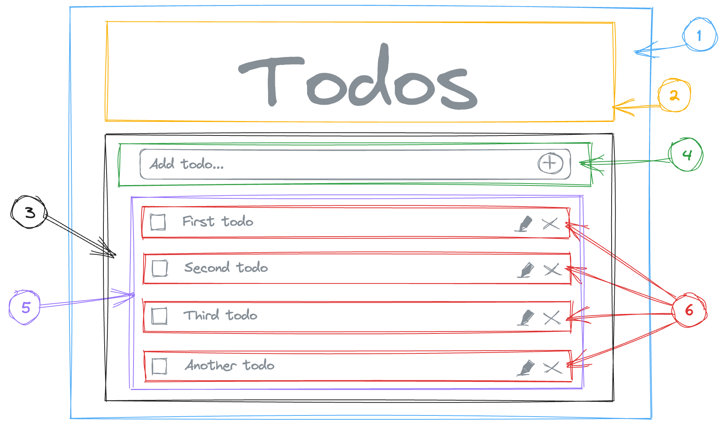

The official documentation for components could be found [here](https://react.dev/learn/your-first-component).

# Props

We have mentioned *props* a few times, but what exactly is that? *Props* are a type of object where the value of attributes of a tag is stored. The word “props” implies “properties”, and its working functionality is quite similar to HTML attributes.

In React, the data can be passed from one component to another component using these props, similar to how the arguments are passed in a function. Inside the component, we can add the attributes called props; however, we cannot change or modify props inside the component as they are immutable.

Consume *title* prop

Pass *title* prop

|  |  |
| --- | --- |
|  |  |

We can pass any kind of data via props – numbers, strings, arrays, objects, etc. Since we are using TypeScript, we need to add some types. It doesn’t really matter if you use interface or type, but most commonly interfaces are used, since they are a bit more flexible.

So, to add types to the Header component, first we need to write an interface for the props. HeaderProps is a good name. Then, we can say that the Header itself is of type *React.FC*. This specifies that it’s a functional component *(demo* [*03-props*](https://github.com/mayyamark/react-training-path/tree/master/03-props)*)*.



We [destructured](https://medium.com/@lcriswell/destructuring-props-in-react-b1c295005ce0) props here

Check this [React and TypeScript cheatsheet](https://react-typescript-cheatsheet.netlify.app/docs/basic/getting-started/basic_type_example) for more information.

There are 2 special props – *children* and *key*.

## *children* prop

The children prop (props.children) allows you to pass components as data to other components, just like any other prop you use. Component tree put between component's opening and closing tag will be passed to that component as children prop *(demo* [*04-children-prop*](https://github.com/mayyamark/react-training-path/tree/master/04-children-prop)*).*

|  |  |
| --- | --- |
|  | Imported from ‘react’ |

More about the *children* prop from the official documentation could be found [here](https://react.dev/learn/passing-props-to-a-component#passing-jsx-as-children).

## *key* prop

React uses the *key* prop create a relationship between the component and the DOM element. This relationship is used to determine whether or not the component should be re-rendered. So, that’s why it’s important to choose unique keys at least among sibling nodes.

The most common case for using keys is when we want to render lists (more on that in the next section, **Rendering** **Lists**). Another usage for this prop is resetting/adjusting the state of an entire component tree by passing a different key to it, but don’t worry about “state”, we are going to cover that in the **State & *useState* hook**. If you want, you can still read more about resetting all state when a prop changes from the official documentation [here](https://react.dev/learn/preserving-and-resetting-state#option-2-resetting-state-with-a-key) and [here](https://react.dev/learn/you-might-not-need-an-effect#resetting-all-state-when-a-prop-changes); or more about adjusting some state when a prop changes from [here](https://react.dev/learn/you-might-not-need-an-effect#adjusting-some-state-when-a-prop-changes).

The official documentation, that explains everything about props, could be found [here](https://react.dev/learn/passing-props-to-a-component).

# Rendering lists

A typical task in React is to display a collection of data. Let’s try to render an array of films data (*demo* [*05-rendering-list*](https://github.com/mayyamark/react-training-path/tree/master/05-rendering-list)). Our array contains objects with the film information – id, title, a small description, the release year, the genre and the main actors. So, first, let’s write our *Film* interface.



Now, we need to iterate over the array and to display some JSX for each element. This is accomplished with the [*Array.map()*](https://developer.mozilla.org/en-US/docs/Web/JavaScript/Reference/Global_Objects/Array/map) method. Here is an UI example.



Did you notice the usage of the *key* prop? As mentioned in the previous section (**Props**), its main usage is for rendering lists. Keys tell React which array item each component corresponds to, so that it can match them up later. This becomes extremely important if your array items can move (e.g. due to sorting), get inserted, or get deleted. A well-chosen key helps React infer what exactly has happened, and make the correct updates to the DOM tree. That’s why it’s important to pick unique keys, at least among sibling nodes. Also, if you miss to add the key prop, you are going to see this error in the console:

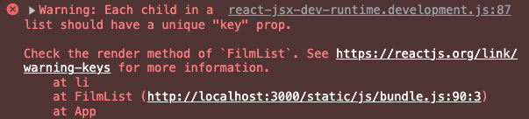

The official documentation, that explains everything about rendering lists, could be found [here](https://react.dev/learn/rendering-lists).

# Conditional Rendering

Sometimes you need to display different UI depending on some conditions. This can be accomplished with regular conditional JavaScript statements – with *if* statement, inline with *&&* or with ternary operator *()* *? () : ()*.

There is a case when you don’t want to render anything at all. In such scenario we just need to return *null*.

## With *If* statement

In the example below, the Greeting component accepts an isLoggedIn prop (*demo* [*06-conditional-rendering-with-if*](https://github.com/mayyamark/react-training-path/tree/master/06-conditional-rendering-with-if)). We use a simple if statement to make the check, so if the flag is false, we won’t render anything. Otherwise, we will display a “Welcome back!” message.



## With logical AND *&&*

We can also use the logical AND && to render UI conditionally (*demo* [*07-conditional-rendering-with-logical-and*](https://github.com/mayyamark/react-training-path/tree/master/07-conditional-rendering-with-logical-and)). Only if the flag is true, we will display the message.



## With ternary operator *() ? () : ()*

Last, but not least, we can use the ternary operator (*demo* [*08-conditional-rendering-with-ternary-operator*](https://github.com/mayyamark/react-training-path/tree/master/08-conditional-rendering-with-ternary-operator)). This is a very common approach. Keep it in mind that nested ternary operators is a bad practice, as it decrease the readability of the code.



The official documentation for conditional rendering could be found [here](https://react.dev/learn/conditional-rendering).

# Adding Styles

There are a few ways of adding styles in React – inline, using CSS modules or with component libraries.

## Inline styles

To specify styles inline, you must use the style attribute. It accepts a JavaScript with camelCased CSS properties (*demo* [*09-inline-styles*](https://github.com/mayyamark/react-training-path/tree/master/09-inline-styles)).



Notice that the value of padding doesn’t need to have a unit, as React appends a *px* suffix to some numeric inline style properties. In cases where you need to use other units, such as *em* or *rem*, it is required to specify the unit with the value explicitly as a string.

The readability of the component reduces dramatically if styles become a lot, and everything gets clunky. Since styles are objects, they can be extracted out of the component as shown below *(demo* [*10-inline-styles-more-readable*](https://github.com/mayyamark/react-training-path/tree/master/10-inline-styles-more-readable)*)*.



Keep in mind that inline styles have highest priority in the [CSS hierarchy](https://developer.mozilla.org/en-US/docs/Web/CSS/Specificity). Another disadvantage is that you cannot use CSS features like media queries, animations, etc.

## Plain CSS

Instead of using inline styles, it's common to import a CSS stylesheet to style a component's elements. All we need to do is to create a CSS file and to import it directly in our component *(demo* [*11-plain-css*](https://github.com/mayyamark/react-training-path/tree/master/11-plain-css)*)*.



Unlike inline styles, it can style your application in virtually any way you need.



One problem might be your naming convention. Once you have a very well-developed application, it becomes harder to think of unique class names for your elements, especially when you have 5 *div*-s wrapped inside each other.

It's important to note that since CSS cascades to all children elements, if you apply a CSS stylesheet to a component it is not just scoped to that component. All its declared rules will be transferred to any elements that are children of your styled component.

## CSS modules

[CSS modules](https://github.com/css-modules/css-modules) are CSS files, in which all class names and animation names are scoped locally by default. They are not specs or an implementation in the browser, but rather a process in a build step (with the help of [Webpack](https://webpack.js.org/) or [Browserify](https://browserify.org/)) that changes class names and selectors to be scoped (kind of like namespaced).

What is great about CSS modules is that they can be used with either normal CSS or SASS. Plus, if you are using Create React App you can start using CSS modules with no setup at all. Any CSS module file must have the name "module" in it and end in the appropriate extension (if we are using CSS or SASS/SCSS), e.g., *App.module.css*, *App.module.sass*, etc.

We can make some small changes to our previous example to start using CSS modules *(demo* [*12-css-modules*](https://github.com/mayyamark/react-training-path/tree/master/12-css-modules)*)*. The first step is to rename our *App.css* to *App.module.css*. Then, in our App.tsx we need to import and use our styles as if it were created as objects.



The benefit of CSS modules is that it helps avoid our problem of class conflicts with normal CSS. The properties that we are referencing turn into unique class names that cannot conflict with one another when our project is built. Below you can see how our generated HTML looks like.

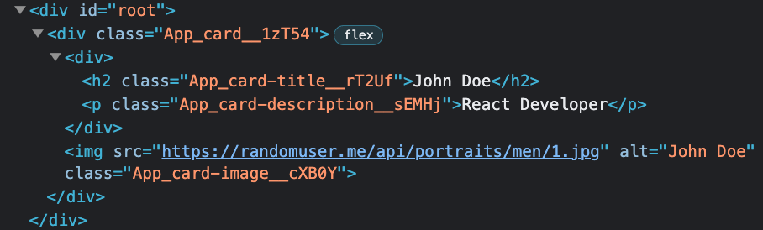

You can find more information about CSS modules [here](https://medium.com/nulogy/how-to-use-css-modules-with-create-react-app-9e44bec2b5c2).

## UI components libraires

[Material UI (MUI)](https://mui.com/) is one of the most popular React design systems, and it is based on [Google's Material Design](https://m3.material.io/) guidelines. It provides a wide range of components – from buttons and forms controls to navigation and layout, as well as theming capabilities and accessibility features. These components work in isolation, which means they are self-supporting and will inject only the styles they need to display.

MUI 5 uses [Emotion](https://emotion.sh/docs/introduction) to style components. To start using MUI we need to add a few dependencies to our project: **yarn add @mui/material @emotion/react @emotion/styled** (or **npm install @mui/material @emotion/react @emotion/styled**). Now let’s imagine how we can implement an autocomplete – we need a lot of CSS and JavaScript for it. [Here](https://www.w3schools.com/howto/howto_js_autocomplete.asp) you can find an implementation. Instead of writing the everything from scratch, MUI 5 exposes a fully featured [*Autocomplete*](https://mui.com/material-ui/api/autocomplete/)component which we can use. In the example below *(demo* [*13-mui-components-library*](https://github.com/mayyamark/react-training-path/tree/master/13-mui-components-library)*)*, we have an autocomplete for searching from a list of countries. When an option is chosen, by using the *onChange* handler, we store that option in a state. The *renderInput* prop is used to specify how to render the input field. In the example we are using MUI’s [*TextField*](https://mui.com/material-ui/api/text-field/) component. To display the selected country’s name we use MUI’s [*Typography*](https://mui.com/material-ui/api/typography/).



You can check this MUI guide [here](https://blog.logrocket.com/guide-material-design-react/) for more explanations.

You can find the top React UI components libraries for 2023 [here](https://dev.to/fredy/top-5-reactjs-ui-components-libraries-for-2023-4673).

# Hooks Overview

[Before React 16.8](https://pusher.com/tutorials/lifecycle-methods-react-16), class components were the only way to track state and lifecycle on a React component (we will cover this terminology later). Function components were considered “stateless”.

In React 16.8 hooks were introduced. Hooks are JavaScript functions that let you “hook into” React state and lifecycle features from function components. This empowered developers to do functional programming in React.

You need to follow these rules when using React hooks:

* Hooks can only be called inside React functional components
* Hooks can only be called at the top level of a component
* Hooks cannot be called conditionally

There is an [ESLint plugin for hooks](https://www.npmjs.com/package/eslint-plugin-react-hooks) that you can add to your project. It will warn you about misusing hooks.

The official documentation for hooks could be found [here](https://react.dev/reference/react).

# *useId* hook

The *useId* hook was introduced in React 18 and it’s the simplest hook of all. It returns a string, which is a unique ID for client and server-side.

The main usage of this hook is to combine HTML elements, which is very useful for forms. Another great thing is that if a component uses the hook and that component appears multiple times on the screen, the generated IDs won’t clash *(demo* [*14-useId*](https://github.com/mayyamark/react-training-path/tree/master/14-useId)*)*.

|  |  |
| --- | --- |
|  | The IDs are going to be different |

Two things to note here:

* Do not use these IDs as CSS selectors. The hook can generate different ID every time for you.
* Do not use these IDs for the *key* prop. Use your data instead.

The official documentation for *useId* could be found [here](https://react.dev/reference/react/useId).

# State & *useState* hook

## State

While building web applications we need to resolve two main problems:

* We often need to change what’s on the screen as a result of an interaction.
* We sometimes need to “remember” things – current page, shopping cart, etc.

Using ordinary, local variables in React cannot resolve these problems, because:

* They cannot trigger re-render of the component.
* They don’t persist between renders. When React renders this component a second time, it renders it from scratch.

React state is a special kind of variable, that allows us to create dynamic and interactive components. Components can either manage their own state or receive it from a parent component. The state itself has a default value, suffers from mutations and it is serializable.

## *useState*

To add state to a component, we need to use the build-in *useState* hook. The *useState* hook is a function, that accepts the initial value of the state. That initial value is used only during the first render. The hook returns an array of two values – the current state and an update function. To modify the state, we always need to use the update function.

Whenever the state changes, the component re-renders.



Initial value of the state

Function that modifies the state

State variable

In the example bellow we have a counter *(demo* [*15-useState*](https://github.com/mayyamark/react-training-path/tree/master/15-useState)*)*. Let’s see how it is implemented. The component renders a heading that displays the number and two buttons for incrementing and decrementing thenumber. The *count* variable is something, that will change over time. To see the changes, the component should re-render. To make that happen, we need to store the count variable in state. First, we need to import *useState* from *react*. Then, at the top of the component, we need to use the hook, by passing to it the initial value, in our case – 0. Then, we can destructure the result of the hook. The current state is named as *count* and the update function – *setCount*. This is a convention – the update function should start with *set* and use the name of the state it modifies. Both buttons should change the *count* state, when being clicked. How? By adding an *onClick* handler to each button and passing to it a callback, that calls the *setCount* function. As you can see, we can pass directly a new value (*count + 1*) or use the previous state (*(prev) => prev - 1*). The modify function can accept another function with parameter, that holds the previous state.



The official documentation for state [here](https://react.dev/learn/state-a-components-memory) and for *useState* could be found [here](https://react.dev/reference/react/useState).

## Batching state updates

Batching is the act of grouping tasks together, so you do them all at once. In React batching is when multiple state updates are grouped into a single re-render for better performance. In React 18 was introduced a huge improvement. Let us break out this batching process React 17 and prior along with React 18 and understand the problems we faced earlier.

### React 17 and prior

Before, in React 17 there were two different behaviors when updating our state with synchronous and asynchronous functions.

Let’s take a look at the simple example below, that uses React v17.0.2 *(demo* [*16-batching-react17*](https://github.com/mayyamark/react-training-path/tree/master/16-batching-react17)*)*.  


We have two states, which we are going to set synchronously, when the button is clicked. We have one *useEffect*, that logs into the console on the first render of the component and any time one of the two states change (we are going to cover it in the **Lifecycle & *useEffect* hook** section). So, let’s run the application. We see the first log, when the component is initially rendered. Both values are *null* as expected. When we click the button, we will see that the message is logged only once for both state updates. Now you have seen that React batched both state updates and re-rendered the component only once. 

What will happen if the state updates are asynchronous? Let’s change our *handleClick* and make a network call to the [JSON placeholder API](https://jsonplaceholder.typicode.com/) to get the data.  


This time if we click the button, we will see that we will have two re-renders – one for each state update. This is a performance bottleneck. Imagine if we have a lot of states coming…

### React 18

In React 18 the batching was upgraded to “automatic batching” *(demo* [*17-batching-react18*](https://github.com/mayyamark/react-training-path/tree/master/17-batching-react18)*)*. This means that React will batch the state updates for us no matter if it is in a simple function containing multiple state updates or a web API and interfaces like *setTimeout*, fetch or a promise containing multiple state updates. If we run the same application with React 18 with disabled Strict Mode (by removing the component wrapper in the *index.tsx* file), we will notice that with both synchronous and asynchronous calls, there is a single log for both state updates.   


What is the benefit? Multiple state updates are batched as one state update and therefore trigger only one re-rendering of the component. This improves the rendering performance especially for larger applications.

The official documentation for batching state updates could be found [here](https://react.dev/learn/queueing-a-series-of-state-updates).

# Lifecycle & *useEffect* hook

## Components lifecycle

Each React component has a lifecycle, containing three phases:

* **Mounting**

This is the phase when the component is inserted to the DOM. We say that this is the initial render of the component.

* **Updating**

The second lifecycle phase. A component is updated whenever there is a change in its state or props. This update is called re-render.

* **Unmounting**

The final phase. It occurs when the component is removed from the DOM.

## *useEffect*

In web development we often need to manage [side-effects](https://www.reddit.com/r/reactjs/comments/8avfej/what_does_side_effects_mean_in_react/) – fetch requests, manipulating DOM directly, using timer functions like *setTimeout()*, using *localStorage*, etc. Let’s say we have a component that renders a list of data. That data should be fetched in the mounting phase of the component. But how can we track different phases? The *useEffect* hook allows us to monitor and manipulate during the three phases of the component. In other words, *useEffect* runs side-effects independently of rendering.

The hook is a function, that accepts two parameters – a callback and a dependency array.

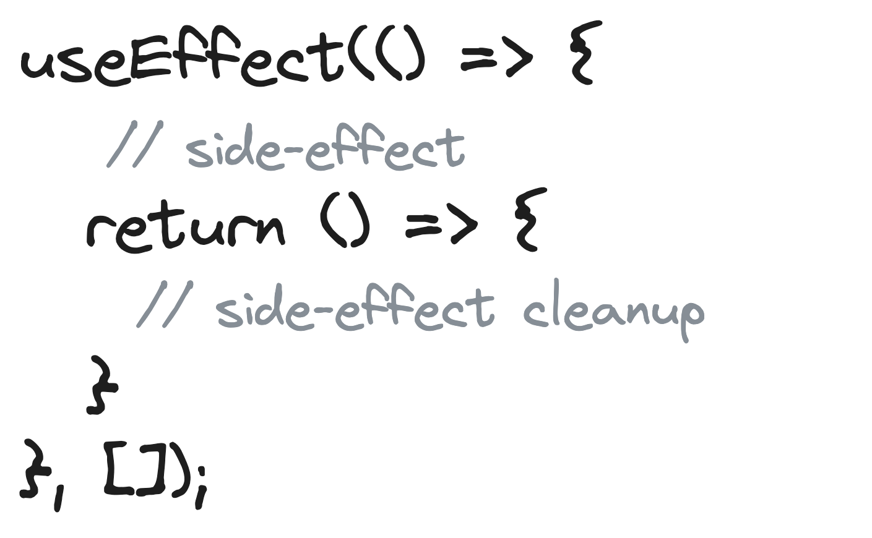

Callback, that contains the side-effect. It can optionally return a cleanup function.

Array of dependencies

### Effect callback

The callback contains our side-effect. This callback is executed in the mounting phase of the component. In the example bellow we have a state for storing todos *(demo* [*18-useEffect-with-promise*](https://github.com/mayyamark/react-training-path/tree/master/18-useEffect-with-promise)*)*. When the component is mounted, the callback, containing the fetch request would be executed. Don’t worry for the second parameter, we are going to explain it later in this section (**Dependancy array**).



In the example we are using promises and we are chaining them with *.then()*. You need to know that you **cannot** directly make the callback function *async (demo* [*19-useEffect-wrong-async-callback*](https://github.com/mayyamark/react-training-path/tree/master/19-useEffect-wrong-async-callback)*)* because:

* *useEffect* expects its callback to either return nothing or a cleanup function (we are going to explain cleanup functions in a second)
* async functions implicitly return a promise



**Wrong!**

If you use the ESLint plugin for hooks, you will see a warning here

Therefore, to use *async*/*await* inside the *useEffect* hook, you can do either of the following:

* Create a self-invoking anonymous function *(demo* [*20-useEffect-with-async-iife*](https://github.com/mayyamark/react-training-path/tree/master/20-useEffect-with-async-iife)*)*



Also called [IIFE](https://developer.mozilla.org/en-US/docs/Glossary/IIFE) (() => {})()

* Create a nested named async function (*demo* [*21-useEffect-with-nested-named-async-function*](https://github.com/mayyamark/react-training-path/tree/master/21-useEffect-with-nested-named-async-function))



The function is created and invoked inside the callback

#### Cleanup function

We have mentioned cleanup functions earlier. Some side-effects need a cleanup to avoid memory leaks – close a socket, clear a timer, remove an event listener, etc. So, if the callback returns a function, then *useEffect* considers that function as an effect cleanup. Here is how the cleanup works:

1. After initial rendering, *useEffect* invokes the callback with the side-effect. The cleanup function is not invoked.
2. On later renderings, before invoking the next side-effect callback, *useEffect* invokes the cleanup function from the previous side-effect execution (to clean up everything after the previous side-effect), then invokes the current side-effect.
3. Finally, after unmounting the component, *useEffect* invokes the cleanup function from the latest side-effect.

Here are a few examples how to use the cleanup function:

* Clear timers and intervals (*demo*s [*22-useEffect-cleanup-timer*](https://github.com/mayyamark/react-training-path/tree/master/22-useEffect-cleanup-timer) and *[23-useEffect-cleanup-interval](https://github.com/mayyamark/react-training-path/tree/master/23-useEffect-cleanup-interval)*)



Use *clearInterval()* for *setInterval()*

* Remove an event listener *(demo* [*24-useEffect-cleanup-event-listener*](https://github.com/mayyamark/react-training-path/tree/master/24-useEffect-cleanup-event-listener)*)*



* Abort fetch request – you can use the [AbortController API](https://developer.mozilla.org/en-US/docs/Web/API/AbortController) *(demo* [*25-useEffect-cleanup-fetch*](https://github.com/mayyamark/react-training-path/tree/master/25-useEffect-cleanup-fetch)*)*. Important note here – if you want to use this API, you need to delete the [*React.StrictMode*](https://react.dev/reference/react/StrictMode) component from your *index.tsx*! This component causes *AbortController* to cancel, since its main idea is to double-invoke effects and their cleanup while developing.



A variable, that stores the API url

* Close web sockets – you can use the [WebSocket API](https://developer.mozilla.org/en-US/docs/Web/API/WebSocket) *(demo* [*26-useEffect-cleanup-socket*](https://github.com/mayyamark/react-training-path/tree/master/26-useEffect-cleanup-socket)*)*.



A variable, that stores the API url

### Dependency array

We saw how we can execute a side-effect when the component is mounting. But how can we manage this execution? That’s the job of the second parameter of *useEffect*. It is an array of dependencies. Inside this array, we can pass the dependencies that the *useEffect* hook will watch. We have three scenarios:

* If we miss the array of dependencies – the effect would be executed on each render.
* If the array is empty – the effect would be executed on the initial render only.
* If there are dependencies – the effect would be executed only if one of the dependencies changes.

The official documentation for *useEffect* could be found [here](https://react.dev/reference/react/useEffect).

# *useLayoutEffect* hook

The *useLayoutEffect* hook is a variation of *useEffect*, but there is one difference:

* *useEffect* runs after React renders your component and ensures that your effect callback does not block browser painting.
* *useLayoutEffect* runs synchronously immediately after React has performed all DOM mutations.

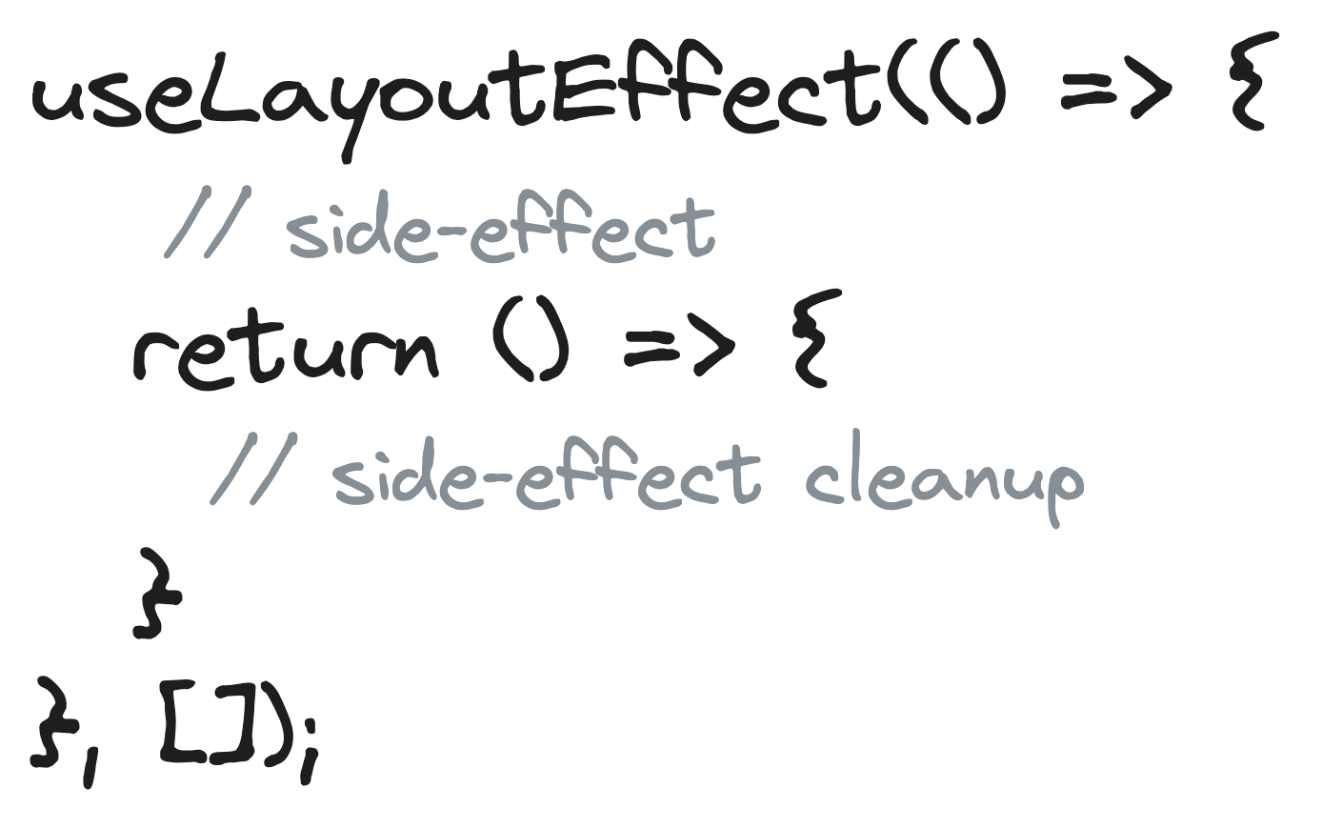

Callback, that contains the side-effect. It can optionally return a cleanup function.

Array of dependencies

The *useLayoutEffect* was designed to handle side effects that require immediate DOM layout updates. This can be useful only if you need to make DOM measurements (like getting the scroll position or other styles for an element) and then make DOM mutations or trigger a synchronous re-render by updating state. Remember, *useLayoutEffect* can hurt performance. Prefer *useEffect* for all other side-effect usages.

Here is an example, where you will need to use *useLayoutEffect*. Imagine you have a lot of input fields, and you want to focus on a specific one when the component is mounted. How to do that? Inside the *useLayoutEffect* hook, we can call the *focus()* method on the input element to give it focus. Since we want this only to run once, we will leave the dependency array empty *(demo* [*27-useLayoutEffect*](https://github.com/mayyamark/react-training-path/tree/master/27-useLayoutEffect)*)*.



Later we will see how to access DOM elements in an elegant way with the *useRef* hook

In [this article](https://refine.dev/blog/uselayouteffect-vs-useeffect/#when-should-you-use-the-uselayouteffect-hook) you can find more examples. The official documentation for *useLayoutEffect* could be found [here](https://react.dev/reference/react/useLayoutEffect).

# *useReducer* hook

Components with many state updates spread across many event handlers can get overwhelming. For such complex state management, React provides the *useReducer* hook. It’s an alternative to *useState*. The main idea is to separate rendering and state by extracting the state management out of the component. How can this be accomplished? By using a reducer function.



Initializer function that computes the initial state lazily

Current state

Initial state

Function that modifies the state by passing action object

Function that specifies how the state gets updated

The *useReducer* hook accepts a reducer function, the initial state and optionally an initializer function. It returns array with two elements – the current state and a dispatch function. Let's decipher what these terms mean.

## Initial state

The initial state is the value the state is initialized with. It can be a value of any type. How the initial state is calculated from it depends on the next *init* argument (initializer function).

## Initializer function

The function allows us to initialize the state lazily. This means that *initialState* will not be used as initial state, but as an argument for the initializer function. The return of this initializer function will be the true initial state. This is useful when creating the initial state is computationally expensive. [This explanation](https://stackoverflow.com/a/62505353) is good as well.



The provided *initialState* value is going to be passed as an argument to the initializer function

The result is going to be the real initial state

## Reducer function

The reducer is a [pure function](https://en.wikipedia.org/wiki/Pure_function) that accepts 2 parameters: the current state and an action object. Depending on the action object, the reducer function updates the state in an immutable manner and return the new state.

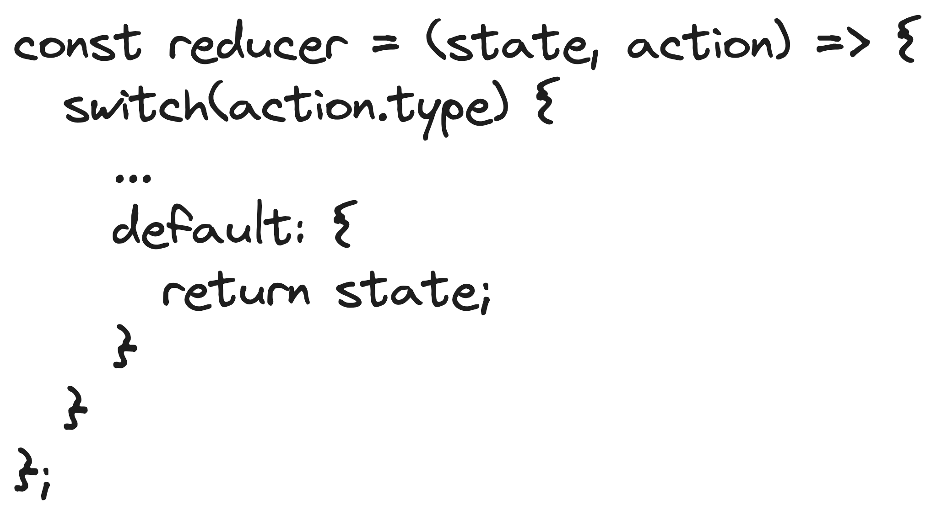

This is a common practice – if no match, return the current state. Another option is to throw an error.

Wait. What is an action object?

## Action object

The action object is an object, that describes how to update the state. It has a required *type* field and an optional *payload* field. The *type* field is a string describing what kind of state update the reducer must do. Typically, the reducer function is a simple switch over this *type* field. The *payload* field stores the additional information about what happened, e.g., the data to insert.

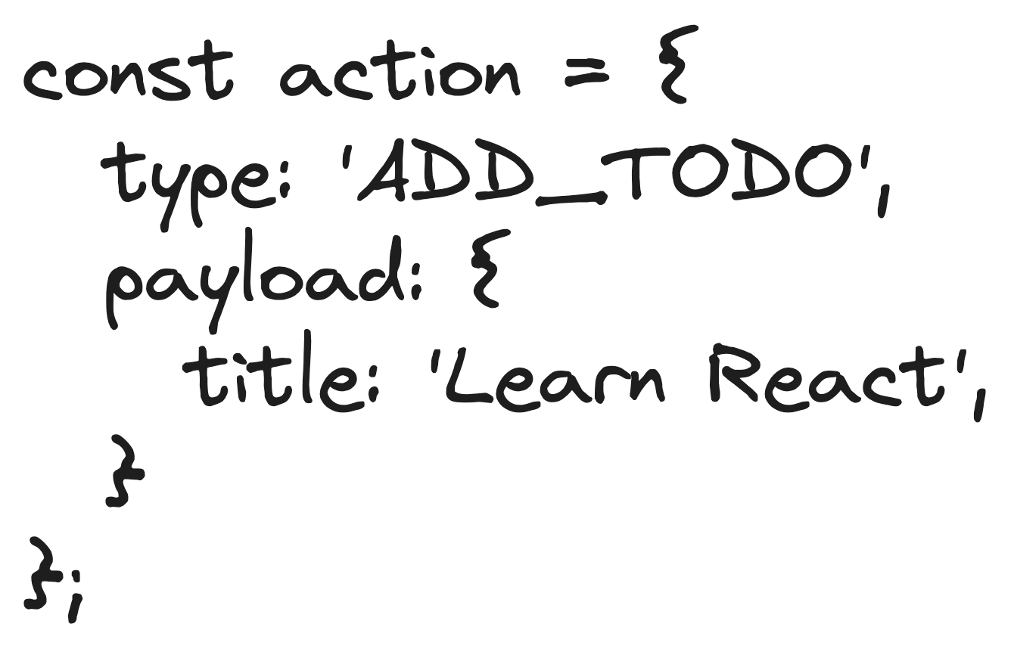

Required field

Optional field

## Dispatch function

The *dispatch* is a special function that dispatches an action object. Whenever you want to update the state, you simply call the dispatch function with the appropriate action object: *dispatch(action)*.

Let’s see how we can implement a todo app by managing the state with the *useReducer* hook *(demo* [*28-useReducer*](https://github.com/mayyamark/react-training-path/tree/master/28-useReducer)*)*. First, we need to define our action types. A common practice is to create a separate file that exports a variable for each type. This allows us to reuse them and avoids the chance to make typos.



Don’t forget to define the types. We need an interface to describe the todo object:



And a type to describe the action object:



The next step is to define our *todosReducer*, that manages the state updates. We will implement two cases:

* Adding a todo

Remember that reducers are pure functions. We can return a new array, spread the current state (the array with the current todos) and to add a new element – the new todo. For this we need the information from the action payload. To create the *id* we will use the incremented length of the array. As it is a new todo, we will assume that the *completed* field is false.

* Toggling a todo

In this case we are using the [*Array.reduce()*](https://developer.mozilla.org/en-US/docs/Web/JavaScript/Reference/Global_Objects/Array/reduce)method on the current state (the todos array). As initial value we use an empty array, which we are going to fill with todos. On each iteration we are trying to find the element, which *completed* field should be changed. To find it we need the provided *id* from the action payload. If there is a match – change the *completed* field and push to the array, otherwise just push the todo. As a result, we receive a copy of the todos array, where one of the todos is updated.



We won’t make any API calls here, so let’s create a hard-coded array with initial todos.



The next step is to use the *useReducer* hook in our component. As a first argument we will pass our *todosReducer*, as a second argument we will pass the hard-coded array. We will also use the third parameter, the initializer function – as we do that, as a parameter the function receives the hard-coded array. We want to enable our users to save their changes, even after they refresh the page. To implement that, we will store our todos in *localStorage* under the *todos* key. So, *localStorage* stores strings, that is why we need to use [*JSON.stringify()*](https://developer.mozilla.org/en-US/docs/Web/JavaScript/Reference/Global_Objects/JSON/stringify) when saving the todos and respectively [*JSON.parse()*](https://developer.mozilla.org/en-US/docs/Web/JavaScript/Reference/Global_Objects/JSON/parse)when we are reading them. Our initializer function tries to read from *localStorage*, if it returns something, we will set it as initial state of our application, otherwise we will use the hard-coded array with todos.

We need a state for the input field for adding todos. We know how to do that. Let’s name it *newTodoTitle*.

Let’s render the UI – we need a form for adding a todo and the list of todos.



Now let’s implement our event handlers. We need one event handler for changing the value in the input, when users try to add a new todo. Let’s name it *handleChangeInput*. You can find more about the naming conventions for event handlers [here](https://jaketrent.com/post/naming-event-handlers-react/). It receives the event object. You can find more information on how to add the correct types to your event handlers [here](https://javascript.plainenglish.io/react-typescript-handling-events-ab13d9778411). So, this event handler just sets the state for the *newTodoTitle* state with the *value* field of the *target*.

Next, we need to implement our *handleSubmit*. It also receives the *event* object. It’s important here to call the [*preventDefault()*](https://developer.mozilla.org/en-US/docs/Web/API/Event/preventDefault) method. The default behavior for submitting is to refresh the page, but we need to avoid that. Now we need to use the *dispatch* function. As type we will pass *ADD_TODO,* and as payload – the data for the new todo. Did you notice what we pass as a title of the todo? The *newTodoText* state. Using the dispatch function will trigger the update of the todos from the reducer function. At the end, we need to set the *newTodoText* state to empty string – this will clear the input field for us.

Our final handler is the one for toggling todos – *handleChange*. It receives the *todo* to update and pass it as an action payload to the *dispatch* function. The action type here is *TOGGLE_TODO*.



Finally, we want to persist the data in *localStorage*, so we need one *useEffect* that saves the todos data when there is a change.



The official documentation for *useReducer* could be found [here](https://react.dev/reference/react/useReducer), for extracting the state logic into a reducer – [here](https://react.dev/learn/extracting-state-logic-into-a-reducer).

# Context & *useContext* hook

React Context allows us to share data (state) across our components by producing global variables. These variables can be passed down and used (consumed) in whatever component we need in our application without using props.

This API avoids the problem of “prop drilling”. “Prop drilling” is a term to describe when you pass props down multiple levels to a nested component, through components that don't need it. Take a look at the example bellow *(demo* [*29-prop-drilling*](https://github.com/mayyamark/react-training-path/tree/master/29-prop-drilling)*)*.



Did you notice the issue? We pass three props to *HomePage*, but it doesn’t use them directly – it only passes them to its children – *Content* and *Button*. That’s the problem of prop drilling. Now this is a very basic example but imagine if the application has lots of components that needs to know if the user is authenticated or not. We will need to pass the user data to all components in the tree and code will become a total mess.

As we mentioned above, in such scenarios we can use React Context to bypass using props entirely. We need to follow a few steps to integrate the API in our application:

* Create the context
* Wrap the component into a context provider
* Consume the context within any component

## Create the context

Let’s fix the code from above by completing this list *(demo* [*30-useContext*](https://github.com/mayyamark/react-training-path/tree/master/30-useContext)*)*. First, we need to create a context with the [*React.createContext()*](https://react.dev/reference/react/createContext) method. This method accepts one argument – the default value. In our case we want to store the user data, the login and logout methods, so our context would be an object with these three fields. Let’s use *null* for *user* and empty functions for both *login* and *logout*. We will modify these in a second. You can find what is the purpose of this default value argument [here](https://react.dev/reference/react/createContext#parameters).

By convention, all context variables should start with capital letter and should include ”Context” in the name. So, we will name our context *UserContext*. We also need to specify the type of the context. Let’s create a reusable interface for that.



Wrap the component into a context provider

The next step is to provide that context to our main component – *App*. We need to wrap the component tree with the [*UserContext.Provider*](https://react.dev/reference/react/createContext#provider) and to specify the [*value prop*](https://react.dev/reference/react/createContext#provider-props)– this is the value that all other components will be able to consume. When this *value* is changed by altering *value* prop of the context provider, then all of its consumers are notified and re-rendered.

The user data is something that changes in time, so in React we need a state variable for this (check the **State & *useState* hook** section). Now let’s define our real *login* and *logout* functions by using that *user* state. The *login* one takes one argument – the *user* object and sets the *user* state with it. The *logout* one just sets the *user* state as *null*. Let’s pass everything to the value *prop* of the *Provider* wrapper.



## Consume the context with *useContext*

The final step is to refactor our consumer components. Now they are able to read what we stored in the UserContext. To do that we need to use the [useContext](https://react.dev/reference/react/useContext) hook.



Context, created with *React.createContext()*

The data, stored in the context

Let’s see how we are going to consume the data from our context. Now, in our *Content* component instead of receiving the user data as a prop, we are just going to import the *useContext* hook, pass our *UserContext* and read the data directly from the context.



We can create a custom hook for consuming our context. For more information, check the **Custom hooks**section.

As mentioned above each change in the React Context triggers re-render. This may not be a performance issue in smaller apps with few state values that are not updated very often. But it is a problem if you will be performing many state updates in an application with a lot of components in your component tree. So, when you decide to use a Context in your application, be sure that you really need it. To help you with that, here is a small list of usages:

* User data – authentication (as we demonstrated earlier)
* Theme data – e.g., dark / light mode
* Location-specific data – preferred language, current location, etc.

These days it is a common approach to combine *useContext* and *useReducer* together to manage the state of a complex application. Many developers think that this combination can replace the usage of [Redux](https://redux.js.org/). You can read more about the usage of *useContext* and *useReducer* [here](https://react.dev/learn/scaling-up-with-reducer-and-context).

The official documentation for React Context could be found [here](https://react.dev/learn/passing-data-deeply-with-context). The official documentation for *useContext* could be found [here](https://react.dev/reference/react/useContext).

# Refs, *useRef* & *useImperativeHandle* hooks

## *useRef*

The *useRef* hook creates a ref. Refs allow you to persist values between renders. E.g., when you want a component to “remember” some information, but you don’t want that information to trigger new renders, you can use a ref. Additionally, the *useRef* hook is instrumental in working with DOM elements.

*useRef* returns a mutable JavaScript object whose *.current* property is initialized to the passed argument (*initialValue*). The returned object will persist for the full lifetime of the component.



A JS object with a *.current* property

*{ current: … }*

Initial value

The most common usage of refs is accessing DOM elements directly – e.g., to focus a node, scroll to it, to measure its size or position. Below we have a simple example *(demo* [*31-useRef*](https://github.com/mayyamark/react-training-path/tree/master/31-useRef)*)*.



We have a *ref* that points to the text area element. When the button is clicked, the the *handleClick* function utilizes [*ref.current.focus()*](https://developer.mozilla.org/en-US/docs/Web/API/HTMLElement/focus) to set the focus on the text area element directly. This demonstrates how the *useRef* hook simplifies the process of working with DOM elements in React.

The official documentation for *useRef* could be found [here](https://react.dev/reference/react/useRef).

## Ref forwarding

Ref forwarding is a technique for automatically passing a ref through a component to one of its children. It’s very useful when building reusable component libraries. *React.forwardRef()* is a higher-order-component, used to pass the ref to a child component. The wrapped component receives a second parameter – the forwarded *ref* from the parent component.

Let’s extract the text area from the example above to a *TextArea* component. In real projects, we will do this if we want to add some custom logic, that we would like to reuse later. To make the example work, we need to wrap the new component in *React.forwardRef() (demo* [*32-ref-forwarding*](https://github.com/mayyamark/react-training-path/tree/master/32-ref-forwarding)*)*.



The *App* component assigns ref to the child *TextArea* component. Then, thanks to being wrapped into *React.forwardRef()*, the child component gets the *ref* from the second parameter and uses it on its *textarea* element. After mounting *ref.current* in the *App* component contains the DOM element from the child *TextArea* component.

The official documentation for *React.forwardRef()* could be found [here](https://react.dev/reference/react/forwardRef).

## *useImperativeHandle*

What if you want to access something else from the child component? For example, to add some custom logic to the focus method. That's where the *useImperativeHandle* hook can help us. This hook accepts three arguments. The first is the forwarded ref. An important note is that *useImperativeHandle* can be used only inside a component wrapped in *React.forwardRef().* The second argument is a function that receives no arguments and returns the new ref value. And the last, third argument is a dependency array.

The main benefit of *useImperativeHandle* is that you can customize the forwarded ref value with whatever you want.

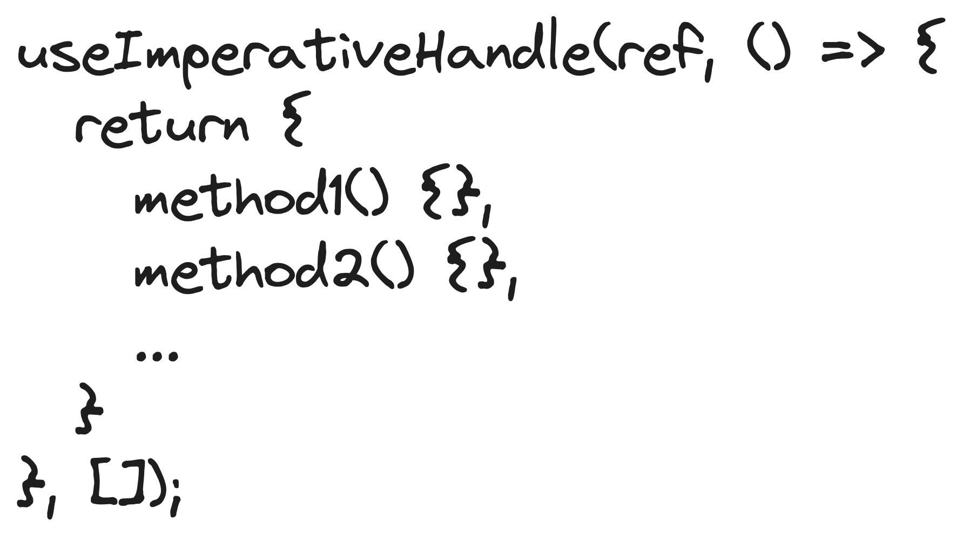

Dependency array

The ref, received from *React.forwardRef()*

A function that returns the ref handle (usually, an object with methods) you want to expose

Now let’s refactor our *TextArea* component from above (*demo* [*33- useImperativeHandle*](https://github.com/mayyamark/react-training-path/tree/master/33-useImperativeHandle)). Our goal is to customize the focus method – when called, we want to change the background color of the text. We will use the *useImperativeHandle* hook.  


So, our TextArea is wrapped in React.forwardRef() – this is required. We use useImperativeHandle to override the [default focus method](https://developer.mozilla.org/en-US/docs/Web/API/HTMLElement/focus) of the text area element by adding a background color and adding a log in the console. Keep in mind that we are directly using the DOM element – we are doing this for demo purposes only and it might be a better idea to use CSS styling to do that in a real project.

So here, useImperativeHandle gives the parent component, in our case the App component, an object with our custom focus method.

The official documentation for *useImperativeHandle* could be found [here](https://react.dev/reference/react/useImperativeHandle).

# Memoizations

[Memoization](https://en.wikipedia.org/wiki/Memoization#:~:text=In%20computing%2C%20memoization%20or%20memoisation,the%20same%20inputs%20occur%20again.) is an optimization technique that allows us to store computation results in cache, and retrieving that same information from the cache the next time it's needed.

When deciding to update DOM, React first renders your component, then compares the result with the previous render. If the render results are different, React updates the DOM. The current vs the previous render results comparison is fast. But there is a way to speed up the process. As mentioned earlier components re-render because of two things: a change in state or a change in props. This is precisely the information we can “cache” to avoid unnecessary re-renders.

How can we accomplish caching in React? By using the *memo()* higher-order component, the *useMemo* hook and the *useCallback* hook. Let’s explain all of them.

## *React.memo()*

React.memo() is a higher-order component (HOC). HOCs are similar to a higher order-functions in JavaScript. Higher-order functions are functions that take other functions as arguments or return other functions. React HOCs take a component as an argument and returns a new component that wraps the original component.

When a component is wrapped in *React.memo()*, React renders the component and memoizes the result. Before the next render, if the new props are the same, React reuses the memoized result, skipping the next rendering. There are a few exceptions, when the component will still re-render:

* When its own state changes
* When a context it’s using changes
* If one of the props is a function or an object



Optional function to manually compare the props

Component to memoize

Memoized version of the component

Did you notice the last bullet? A component, wrapped in *React.memo()* re-renders whenever any prop is not shallowly equal to what it was previously. This happens, because React uses [*Object.is()*](https://developer.mozilla.org/en-US/docs/Web/JavaScript/Reference/Global_Objects/Object/is) to compare each prop and both *Object.is({}, {})* and *Object.is(() => {}, () => {})* return *false*. To change this behavior the *React.memo()* accepts a second argument – a custom comparison function. This function accepts two arguments – the old props and the new props and returns a boolean – *true* if we want to make the component to re-render or *false* – if we don’t. The React team suggests using this function very wisely.

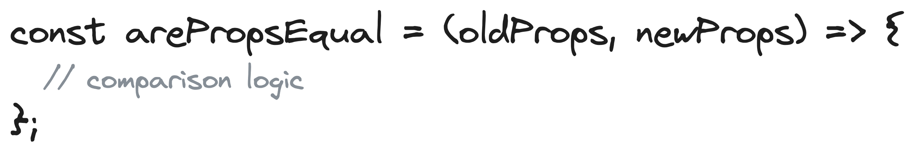

Props from previous render

Props from upcoming render

When to use this HOC then? Here is the perfect example *(demo* [*34-memoizations*](https://github.com/mayyamark/react-training-path/tree/master/34-memoizations)*)*. Imagine you have a component that only renders the title of your application and nothing else. This component would re-render any time its parent re-renders. In such cases the perfect solution to stop unnecessary re-renders is using *React.memo()*.



The official documentation for *memo()* could be found [here](https://react.dev/reference/react/memo).

## *useMemo*

*useMemo* is a hook that allows us to cache a value. This is helpful when:

* We make expensive calculations, and we don’t want to make them on each re-render.
* We want to persist a value between re-renders, and we don’t won’t to lose it between re-renders.



Dependency array

Function that computes the result to cache

*useMemo* optimizes performance by recomputing the memoized value only when one of the passed dependencies changes. Keep in mind that *useMemo* runs during rendering so we need to ensure that we do not use anything that is not used during rendering, like side effects.

Here is an example – imagine if you want to have a random number and you want to keep that random number unchanged during all re-renders. In this case you can use *useMemo* to cache it *(demo* [*34-memoizations*](https://github.com/mayyamark/react-training-path/tree/master/34-memoizations)*)*. The dependency array should be empty, since we want to calculate the value only on the first render.



The official documentation for *useMemo* could be found [here](https://react.dev/reference/react/useMemo).

## *useCallback*

*useCallback* is a hook that returns a memoized version of the passed callback that only changes if one of the dependencies has changed. This means that this function only gets re-defined if any of its dependencies in the dependency array changes.



Function to cache

Dependency array

Common usages of *useCallback* are:

* Caching a function in order to trigger unnecessary re-renders of child components.
* Preventing an effect (in *useEffect*) from firing too often. More on that [here](https://maxrozen.com/stop-useeffect-running-every-render-with-usecallback).

Here is an example that demonstrates the first usage. Again, we have a counter app *(demo* [*34-memoizations*](https://github.com/mayyamark/react-training-path/tree/master/34-memoizations)*)*. This time we have a custom Button component, which is just a styled HTML button. We use that component twice in our app – the first one increments our *count* state, the second one just logs a message in the console.   


Each time we click on the Increment button, the Log button re-renders as well. Why? Because we are updating the state, which triggers a re-render of the *App* component, then a new reference of the *handleLog* function is created and that automatically triggers a re-render of the Log button component. We can skip this child re-render by wrapping the *handleLog* function in *useCallback*.



The official documentation for *useCallback* could be found [here](https://react.dev/reference/react/useCallback).

Memoization can increase performance for some functions. But, if we use it for every component rendering, it might decrease performance since it stores results that increase the memory used for the program. We should only use memoization when there is a clear benefit to doing so. If the re-render is caused by tasks that are not computationally heavy, it may be better to solve it in other way or leave it alone. You can also check [this article](https://kentcdodds.com/blog/usememo-and-usecallback) for more information.

# *useTransition* hook

Before React 18, rendering was synchronous. This meant that once React started rendering, nothing could stop it until it completed rendering the component. However, with concurrent rendering, React can pause the rendering and continue with it later or abort the rendering altogether. This is an important implementation that allows us to provide a more fluid user experience to our users. Let’s see how with an example *(demo* [*35-synchronous-rendering*](https://github.com/mayyamark/react-training-path/tree/master/35-synchronous-rendering)*)*.

We have a state that stores the value of numeric input field and a *List* component, that accepts the input value and renders the numbers, that starts with that number. For example, we can filter out the numbers that start with 1 by typing “1” in the input field.



Since there are 20,000 elements in the array, filtering is going to be a bit of a time-consuming process. We can observe this when we try to enter a number into the textbox. There will be a lag in the typed value appearing in the textbox because the render following every keystroke is going to take some time. Now, what if we can delay the filtering function and allow the typed text to appear in the textbox immediately? This is what concurrency in React accomplishes.

When we use concurrency, we can either pause or cancel the rendering that involves filtering the numbers and give priority to updating the state of the textbox. Now, let’s see how we can implement this.

We can use the *useTransition* hook to tell React that a certain state change will result in an expensive rendering. React will then deprioritize this state change allowing other renderings to take place faster providing a very responsive UI. Such expensive renderings are called transition updates and the ones that should take place immediately are called urgent updates. Usually, typing, clicking, and pressing are considered urgent updates as they should provide users with an immediate response to ensure a good user experience.

By default, every state change is considered an urgent update. We can specify a transition update by using the *useTransition* hook. When we call the *useTransition* hook, we get an array with two elements. The first element is a boolean value that specifies if the rendering is pending or not. The second element is the *startTransition* method. This method accepts a callback function. Any state update we perform within this callback function will be considered a transition update.



If *true*, there is a pending transition

Marks a state update as a transition

Let’s fix our App by using the useTransition hook (*demo* [*36-useTransition*](https://github.com/mayyamark/react-training-path/tree/master/36-useTransition)). We need two states – one for the input value (inputValue) and one to filter the array (query). We will refactor our handleChange by adding the startTransition method. Inside, we will mark the query update as a transition. Finally, instead of passing the inputValue state to the List component, we will send the query state.



So, what is the result? When you first enter a key, React will update the first state, perform a render and then update the second state and start the more expensive render. Now, if you enter another key, since React knows that this is a transition update, it will abort the transition rendering, perform the urgent render, and then start a new transition render. This means that the user will not experience any lag while typing into the input field.

The official documentation for useTransition could be found [here](https://react.dev/reference/react/useTransition).

# Debounce, throttle & *useDeferredValue* hook

## Debounce and throttle

Debouncing and throttling are higher order functions used to increase the performance of your JavaScript function calls by limiting or slowing down the number of continuous invocations. This may seem complicated, but the basic idea is – limit the number of times you call a function. Throttling and debouncing both do this but there are subtle differences between the two.

Debouncing waits until a continuous function call is stopped for an amount of time, then it invokes the function. It’s a good method for controlling events that require sporadic user actions, such as typing in an input field or clicking a button.

Throttling limits the number of times a function is called but calls the function continuously while spacing out the invocation intervals. It’s useful for cases where the user is carrying out a smooth or continuous event, such as scrolling or resizing.

In the illustration below you can see a download button, being clicked multiple times.

* If the function, that is fired onclick, is not limited it is going to be executed on each click of the button. Imagine how many redundant API calls are that.
* If we apply throttle on the function, the function would be fired on the first click, then each following execution would be triggered after the specified interval.
* If we apply debounce the function would be executed when the user stops clicking the button and after the specified delay.



You can find the more information and the JavaScript implementation for debounce [here](https://codedamn.com/news/javascript/debouncing-in-javascript) and for throttle – [here](https://codedamn.com/news/javascript/throttling-in-javascript).

## *useDeferredValue*

Do you remember the example for filtering a list of numbers from the ***useTransition* hook** section? The issue was that there are 20,000 elements in the array and the filtering is a slow process. The code snippet is below *(demo* [*35-synchronous-rendering*](https://github.com/mayyamark/react-training-path/tree/master/35-synchronous-rendering)*)*.



So, previously we fixed the problem by using the *useTransition* hook *(demo* [*36-useTransition*](https://github.com/mayyamark/react-training-path/tree/master/36-useTransition)*)*. There, we created a *query* state in the parent component (*App*) and we told React that the *setQuery* method will trigger a transition update.

Now, let’s imagine that we have no control over the parent component, but we do have control over the child component (*List*). In this case, we can try to tell React that the received prop in the child component will trigger a transition update. Sounds complicated, but let’s see how we can implement that.

So, a solution might be to use the debounce technique in the *List* component to defer the *query* prop (the user input) for the specified amount of time. This can make the overall experience a little better, but still – how much time do we need?

React 18 introduces the *useDeferredValue* hook to debounce thing, but in a more streamlined manner. The difference between a usual debouncing and this hook is React will intelligently work on the update as soon as other work finishes instead of a fixed amount of time that we specify in a debouncing function.

Essentially, the *useDeferredValue* hook is React’s answer to handle debouncing natively. It accepts a value and returns a new copy of the value that will defer to more urgent updates like so.



The value to defer

The deferred value

How this works is, under the hood, the *useDeferredValue* hook will return the previous state (deferred value) of the value passed into it for the current render of that component and then render the new value after the urgent render has completed. Like displaying filtered numbers’ lists in our case.

Let’s see how we need to refactor our *List* component *(demo* [*37-useDeferredValue*](https://github.com/mayyamark/react-training-path/tree/master/37-useDeferredValue)*)*. It’s really simple – we just need to defer the *query* prop with *useDeferredValue* and make the filtration with the deferred value.



The official documentation for *useDeferredValue* could be found [here](https://react.dev/reference/react/useDeferredValue).

# Custom Hooks

Suppose you have some logic that makes use of some built-in hooks, and you need to use the logic in multiple functional components. So, the easier way to do it is creating a separate function that wraps the logic inside it and then call it from those components. Here, the separate function you created is the custom hook.

Creating a custom hook is the same as creating a JavaScript function. It can use other hooks inside it, return anything you want it to return, take anything as parameters. It is important to name your custom hooks starting with “use”, because without it React can’t realize that it is a custom hook and therefore can’t apply the rules of hooks to it. So, you should name it starting with “use”.

There is a common pattern when displaying some data:

* Make a HTTP request to get the data
* Display a loader, while waiting the request to finish
* Display an error message, when there is an error.

For that we need three states. Let’s create a custom useFetch hook that will manage these states for us (*demo* [*38-useFetch-custom-hook*](https://github.com/mayyamark/react-training-path/tree/master/38-useFetch-custom-hook)). We want to make our hook as reusable, as possible, that is why it will take the API URL as a parameter.

So first, we need to declare our states. Our data state is initially empty and empty variables are initialized with null. At some point it will become an array of any kind of objects. Because there are two possibilities – null or array of objects, we must specify these two types as shown.

Next, we will use the useEffect hook to make the API call. Inside useEffect, we will set the loading state to true and give nulls for both error and data. Then, we will use the [AbortController API](https://developer.mozilla.org/en-US/docs/Web/API/AbortController) in order to be able to clean up the effect. As mentioned earlier make sure you have removed the [*React.StrictMode*](https://react.dev/reference/react/StrictMode) component from your index.tsx. There are a few steps next:

* Make the HTTP request
* Convert the response to JSON format
* Set the data state with the data from the response
* Catch the error if there is one
* Set the loading state to false

From our custom hook we will return the three state variables.



How can we consume our custom hook? We just need to import it and to pass an API URL. We can destructure the result.



Another common usage of custom hooks is when we create contexts. Did you remember the example in the **Context & *useContext* hook**section? After we define our context, in order to consume it we need to pass it in the useContext hook every time. We need to import both the hook and our context. Isn’t that something that we do everywhere? We can create a custom hook that reads the specific context, that we want to use. In that case we will import only the custom hook. Here is how we can implement our useUser custom hook by using the UserContext from earlier (*demo* [*39-useUser-custom-hook*](https://github.com/mayyamark/react-training-path/tree/master/39-useUser-custom-hook)).



And how are we going to use it?



The official documentation for custom hooks could be found [here](https://react.dev/learn/reusing-logic-with-custom-hooks).

# Suspense & Error boundaries

Before moving to boundaries, let’s see how we were handling loading and errors so far. We are going to fetch pokemons from the [PokeAPI](https://pokeapi.co/). While waiting the request to resolve, we want to display a “Loading…” message and if an error occurs to render an “An error has occurred” message. In this case we need three states – one to store the data, one for tracking the loading and one for the error *(demo* [*40-loading-and-error-with-state*](https://github.com/mayyamark/react-training-path/tree/master/40-loading-and-error-with-state)*)*.  


You can see there is quite a bit of code that we’ve had to add to support the data fetching as well as control the loading and catching errors. Here is where Suspense and Error boundaries come.

## Suspense

### Handle loading

*Suspense* is a build-in component, that we can use to wrap our components, that make asynchronous requests (e.g., promises, data fetching). When one of the wrapped components makes a request, Suspense automatically detects that and allows us to show a custom loading UI (fallback). What’s the benefit? There’s no need of *loading* states (or props) all over our application.

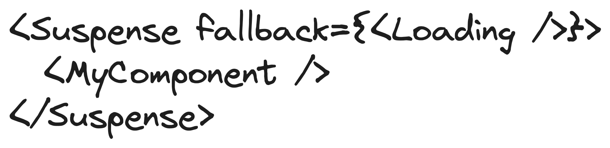

This component would be displayed while *MyComponent* is loading

But how exactly does React know that a network call is pending? As far as we’ve reviewed, *Suspense* only renders a fallback component while waiting. Where in the code do we communicate to React that we’re making a network call? Before continuing, make sure you know the states of a [Promise](https://developer.mozilla.org/en-US/docs/Web/JavaScript/Reference/Global_Objects/Promise):

* pending – the request is still processing
* fulfilled – the request has returned some data and we got a 200 OK status
* rejected – something went wrong, and we got an error

So, the logic used by Suspense is if the code throws an exception, because it’s either loading or because it failed, show the fallback, if instead it did resolve successfully, show the children components. To implement this behavior, we need to wrap our request with the following function *(demo* [*41-suspense*](https://github.com/mayyamark/react-training-path/tree/master/41-suspense)*)*:



The code above will check our promise's state, then return a function called *read*, which we'll invoke later in the component.

Now, we'll need to wrap our *fetch* with it in a very simple function:  


Once everything is wrapped up on the fetching side of things, we want to use it in our component. Unlike how we did earlier, where we fire the request in a *useEffect*, this time we want to call the request, using the *read* method we exported in the wrapper, right at the beginning of the component, outside any hooks, so our *Pokemons* component will start like this:  


What is happening here, is when we call the component, the *read* function will start to throw exceptions until it's fully resolved, and when that happen it will continue with the rest of the code, in our case to render it.

Now, it’s time to use *Suspense*. We can wrap individual components or the whole application. In our case, we are going to wrap everything in our *App*, so, while we are waiting the pokemons request, we will see the fallback UI.   


### Lazy loading

Another usage of Suspense if for loading components lazily. Lazy loading is a design pattern for optimizing web and mobile apps. The concept of lazy loading is simple – initialize objects that are critical to the user interface first and quietly render noncritical items later.

Before we continue, we need to explain code-splitting and dynamic imports.

With the advent of [ES modules](https://nodejs.org/api/esm.html#modules-ecmascript-modules), transpilers ([Babel](https://babeljs.io/)) and bundlers ([Webpack](https://webpack.js.org/), [Browserify](https://browserify.org/)), we can write JavaScript applications in a completely modular pattern for easy maintainability. Usually, each module is imported and merged into a single file called a bundle, then the bundle is included on a webpage to load the entire app. As the app grows, the bundle size increases and eventually impacts page load times. So, code-splitting is the process of dividing a large bundle of code into multiple bundles that can be loaded dynamically. This helps us avoid performance issues associated with oversized bundles without actually reducing the amount of code in your app.

One way to split code is to use dynamic imports, which leverage the [*import()*](https://developer.mozilla.org/en-US/docs/Web/JavaScript/Reference/Operators/import) syntax. Calling *import()* to load a module relies on JavaScript [promises](https://developer.mozilla.org/en-US/docs/Web/JavaScript/Reference/Global_Objects/Promise). Hence, it returns a promise that is fulfilled with the loaded module or rejected if the module can’t be loaded. As we use the [Create React App](https://create-react-app.dev/) template, using dynamic imports happen on fly, but if you are working with a custom Webpack configuration, you need some [additional configurations](https://webpack.js.org/guides/code-splitting/). *React.lazy()* makes it easy to create components that are loaded using dynamic *import()*, but rendered like regular components. This automatically causes the bundle containing the component to load when the component is rendered. *React.lazy()* takes as its argument a function that must return a promise by calling *import()* to load the component. The returned promise resolves to a module with a default export containing the React component.



Function, that returns a Promise

Finally, to display a loader, while the lazy component is being loaded, we need to use *Suspense*. Let’s wrap all that terminology with an example *(demo* [*42-lazy-loading*](https://github.com/mayyamark/react-training-path/tree/master/42-lazy-loading)*)*. We have an image component, that we want to load lazily in our *App* after clicking a button. Of corse, we need a state for showing the image, *React.lazy()* for the dynamic import of the *Image* component and *Suspense* for displaying a loading indicator, while *Image* is being loaded.  


You can find more information for *React.lazy()* in the official documentation [here](https://react.dev/reference/react/lazy) and for *Suspense* – [here](https://react.dev/reference/react/Suspense).

## Error Boundary

What happens when an error occurs? There is another feature in React – error boundary. It allows us to catch and gracefully handle errors that occur in our components. For example, in our situation with data fetching, if there is an error for some reason, we can use error boundary to show an error message to inform the user in a very similar way to *Suspense* with loading UI.

There is no build-in component, for this, but we can write our own. In React 18 error boundaries are the only components that are still a class and cannot be functional ones. Here is what we need to do to implement our own error boundary:

* Create a class, that extends [*React.Component*](https://react.dev/reference/react/Component)
* Define an *error* state, which is going to be used to display the error UI
* Define [*getDerivedStateFromError*](https://react.dev/reference/react/Component#static-getderivedstatefromerror)and[*componentDidCatch*](https://react.dev/reference/react/Component#componentdidcatch)inside the class
* Render the children components or the error UI, if there is an error

The static *getDerivedStateFromError* is being called, when a child component throws an error during rendering. The parameter *err* is usually an instance of [Error](https://developer.mozilla.org/en-US/docs/Web/JavaScript/Reference/Global_Objects/Error/Error), but keep in mind that in JavaScript we can [throw](https://developer.mozilla.org/en-US/docs/Web/JavaScript/Reference/Statements/throw) any value. The method should return the state, telling the component to display the error UI.

The *componentDidCatch* also should be implemented. This method lets us to log that error to an error reporting service in production. It accepts the error *err* (instance of [Error](https://developer.mozilla.org/en-US/docs/Web/JavaScript/Reference/Global_Objects/Error/Error)) and *info* – an object containing additional information. The *componentStack* field contains a stack trace with the component that threw, as well as the names and source locations of all its parent components.

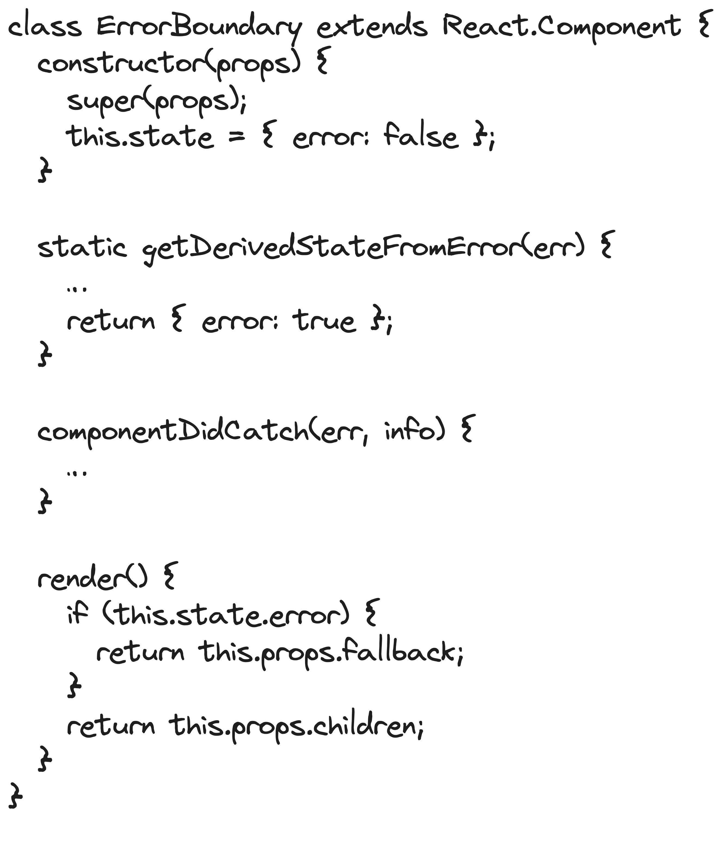

Tells React to render the error UI (fallback)

Lets us to log the error

Returns the error UI (fallback) or the children

In [class](https://developer.mozilla.org/en-US/docs/Web/JavaScript/Reference/Classes) components, props are passed with the [super keyword](https://developer.mozilla.org/en-US/docs/Web/JavaScript/Reference/Operators/super), state is defined inside the [constructor](https://developer.mozilla.org/en-US/docs/Web/JavaScript/Reference/Classes/constructor)

So, let’s write our error boundary *(demo* [*43-error-boundary*](https://github.com/mayyamark/react-training-path/tree/master/43-error-boundary)*)*. We need to define an interface for both props and state. Our props would include *children*, as it the component Is a wrapper, and a *fallback* – our error UI. The state includes only an *error* flag. When an error occurs in the application, in *getDerivedStateFromError* we change the value of the flag and in *componentDidCatch* we log that error and the information about it in the console.  


Our next step is to use the component. Just like *Suspense*, you can wrap individual components, but it’s a common practice to wrap the whole application. In case you use both *ErrorBoundary* and Suspense – usually *ErrorBoundary* wraps *Suspense*. So, let’s say we are rendering some content, coming from our API in our *App* component.   


Now, to mimic that we receive an error in our *Content*, we are simply going to throw an Error inside it.



Now, if we run the application, we are going to see something like this:

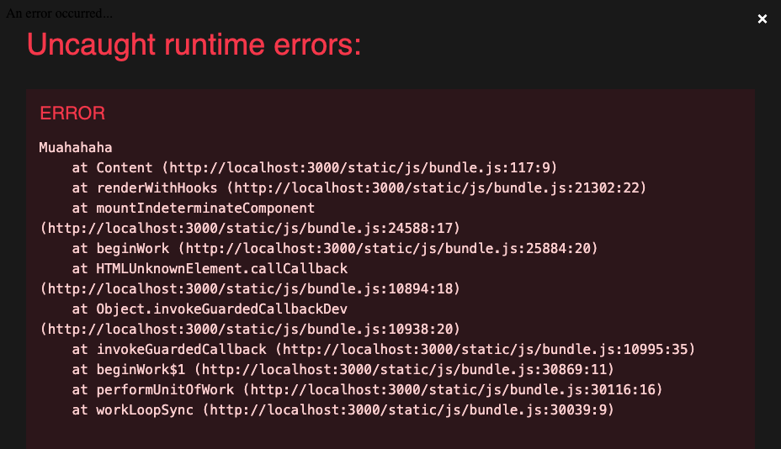

This is expected, because we are in development mode. If you close the window, you will see our error UI and that is what our users would see in production mode. Also, if you open the DevTools (CTRL + F12 for Windows/Linux or Command + F12 for Mac), you will see the message from *componentDidCatch*.

You can find additional information for error boundary in the official documentation [here](https://react.dev/reference/react/Component#catching-rendering-errors-with-an-error-boundary).

# Handling Forms in react

Forms allow users to directly input and submit data, which is essential for every project. Since React applications are single page applications, you won’t submit the information directly from the form to a server. Instead, you’ll capture the form information on the client-side and send or display it using additional JavaScript code.

## Controlled and Uncontrolled components

React forms present a unique challenge because you have two options for managing your forms:

* **With a controlled component**

Here React fully controls the element by setting and updating the input value directly. The form data is stored in state (check the **State & *useState* hook** section). Each keystroke updates the state. This makes the component to re-render, which allows us to make form validations, while the user types. You can also render your form dynamically.

* **With an uncontrolled component**

Here React is not setting the form values for us. Instead, we need to use refs to collect the data (check the **Refs, *useRef* and *useImperativeHandle* hooks** section). Ref updates don’t trigger re-renders, which means that we can check if our validations pass, after the form is submitted.

Let’s see in action how these two types of forms behave, starting with the controlled one.

### Controlled component

#### Basic controlled form

We are going to implement a form with two input fields – for email and password *(demo* [*44-controlled-form*](https://github.com/mayyamark/react-training-path/tree/master/44-controlled-form)*)*. To do that with a controlled form, we will need to define a state, where we will store the input values. The initial values, of course, are empty strings.



Our submit handler will just log the values. It’s important to call the [*event.preventDefault()*](https://developer.mozilla.org/en-US/docs/Web/API/Event/preventDefault) inside the handler. This function prevents the form from actually submitting, giving you a chance to validate or process the input before submitting it to the server or updating the state of your React component. Usually, when a form is submitted, the input fields gets cleared. With controlled components, we need to call the state setter function with the default values.



Finally, it’s time to render our form. The main thing for controlled forms is that when the value in any of the inputs is being changed by the user, the state setter function will be called. This will make the whole component to re-render. What is the benefit? Controlled forms are more predictable and easier to debug. So, as mentioned in the **State & *useState* hook section**, mutations are forbidden, that’s why in our change handlers, we need to make a copy of the *form* state, then to update the corresponding value, and at the end to pass the updated data to the state setter function. As, you can see, the logic is almost the same, so you can extract it and then reuse it, if you want.

We can also make a small form validation here, by disabling the submit button, when the form values are empty. In real projects, it’s also common to disable that button, when sending the form values to the backend.



#### Controlled form with validations

We can perform validations on each keystroke, since the component re-renders all the time. In the [*45-controlled-form-validations*](https://github.com/mayyamark/react-training-path/tree/master/45-controlled-form-validations) demo you can find an example how we can refactor the form to perform that (of course, you can think of another implementation). Our state now includes nested objects with *value* and *errorMessage* fields.



In the change handlers, we update the *value*, but also we perform our validations and if one of them fails, we update the *errorMessage* field as well. Here is how the change handler of the *email* field looks like:



#### Dynamically-rendered controlled form

Earlier, we mentioned that with controlled forms it’s possible to render the form itself dynamically. However, this can make them more complex to implement, read and debug in larger projects with many levels of nested form data. We won’t recommend this approach. You can find an example of the refactored form in demo [*46-dynamically-rendered-controlled-form*](https://github.com/mayyamark/react-training-path/tree/master/46-dynamically-rendered-controlled-form).

### Uncontrolled component

#### Basic uncontrolled form

Let’s take a look at how we can implement the same form with uncontrolled form (*demo* [*47-uncontrolled-form*](https://github.com/mayyamark/react-training-path/tree/master/47-uncontrolled-form)). We have refs that store references to our input elements (check **Refs, *useRef* and *useImperativeHandle* hooks**section). Here typing in any of the inputs doesn’t trigger re-render of the *App* component. So, we collect the form data through the refs in the submit handler. Finally, to clear the fields after submitting the form, we need to mutate the refs.



#### Uncontrolled form with validations

As you can see, uncontrolled forms are simpler to implement, but they can be more difficult to track and manage in larger projects. Also, applying validations becomes a bit complicated task, as they can be fired only after submitting the form. Let’s see how can we implement that (*demo* [*48-uncontrolled-form-validations*](https://github.com/mayyamark/react-training-path/tree/master/48-uncontrolled-form-validations)). First, it’s important to add the [*noValidate*](https://developer.mozilla.org/en-US/docs/Web/HTML/Element/form#attributes_for_form_submission) attribute to the form element. This removes the [build-in browser form validations](https://developer.mozilla.org/en-US/docs/Learn/Forms/Form_validation#using_built-in_form_validation). Then, we will add a few HTML attributes to the input fields – [*required*](https://developer.mozilla.org/en-US/docs/Web/HTML/Attributes/required) to both inputs, and [*pattern*](https://developer.mozilla.org/en-US/docs/Web/HTML/Attributes/pattern) to the *email* input.

The next step is modifying the submit handler. Here is what we need to do:

* Add a “*submitted*” *className* to the *form* element to improve the UX (more on this in a moment)
* Query by the [*:invalid*](https://developer.mozilla.org/en-US/docs/Web/CSS/:invalid) pseudo-class to find the first invalid field
* Move to the focus to the first invalid field, if any
* Check if the form is valid with the [*checkValidity()*](https://developer.mozilla.org/en-US/docs/Web/API/HTMLSelectElement/checkValidity) method
* Submit the data, if the form is valid



So, as mentioned, we want to improve the UX. We will add red border and outline to the invalid fields. For that, we need a CSS module (check the **Adding Styles** section):



Now let’s explain why we need to attach the *submitted* *className* to the *form* element. Using just the *:invalid* pseudo-class in our CSS would cause red highlighted input boxes as soon as the page loads, when our goal is to apply the styles after submitting the form.

The official documentation for controlled and uncontrolled components could be found [here](https://react.dev/learn/sharing-state-between-components#controlled-and-uncontrolled-components).

## React Hook Froms

Instead of manually writing all of the code and handling complex forms with validation logic, we can use the most popular library for this, [React Hook Form](https://www.react-hook-form.com/).

Let’s try to implement our form of email and password fields with React Hook Form (*demo* [*49-react-hook-form*](https://github.com/mayyamark/react-training-path/tree/master/49-react-hook-form)).

First, we need to add it as a dependency of our application with **yarn add react-hook-form** (or **npm install react-hook-form**).

For our purposes we need to import the [*useForm*](https://www.react-hook-form.com/api/useform/) hook. This is a powerful jook to validate our form with minimal re-renders. It accepts an options object and returns another object with a lot of methods and properties. We are going to use only 3 of them.



Here you can define things, such as the default values; the validation resolver, if you use a validation library (e.g., [*Yup*](https://github.com/jquense/yup)), etc.

Methods and properties for registering and unregistering fields, submitting and clearing the form, handling the errors and values, getting the current state, etc.

* [*register*](https://www.react-hook-form.com/api/useform/register/)

We are going to add this function to each input field to register it. How? *Register* accepts two arguments – the input’s *name* and an optional *options* object. It returns an object with *onChange*, *onBlur*, *ref* and *name* fields. Attaching these as props to our input field is called “to register” the field.

Let’s talk more about the optional argument, the *options* object. This is where we define our validations. We specify the validation name, e.g., *required*, *maxLength*, *minLength*, *pattern*, etc., and next to it we define a nested object, with a *value* and a *message* field. The message field is exactly the error message we want to display if the validation fails.

Name of the field



Properties to pass to your field in order to register it.

You can pass your validations here

* [*formState*](https://www.react-hook-form.com/api/useform/formstate/)

This is an object. We are interested in its nested property – the errors object, which includes the validation errors of each registered field, if any.



Object, storing the validation error information for each registered field. This includes the validation type and message, and a ref to the field.

Other formState values, such as is the form loading, touched, valid, submitted, etc.

* *[handleSubmit](https://www.react-hook-form.com/api/useform/handlesubmit/)*

This function will receive the form data if the form validation is successful. We call it when the form is submitted.



A successful callback. It’s fired if all validations pass. The *data* object includes fields of all our registered fields.

An error callback. It’s fired if one or more of the validations fail. The *errors* object includes the error messages.

So, to implement our login form, we need to extract these 3 properties from the *useForm* hook. Then, we need to pass the *handleSubmit* function to the *onSubmit* handler of the form. For our purposes, we only want to log the values.

The next step is to render our input fields for email and password. We are going to spread the result of the *register* function inline. As mentioned above, the first argument is the *name* of the field, then, as a second argument we are going to pass our validations. Right after each input element, we are going to render the error message, if there is one.

There is also another approach – you can use the *isValid* field, extracted from the *formState* object to disable the submit button, until all your validations pass. If you choose this, you need to provide some helper text below your input fields, to inform the user what are the requirements.



## Formik

Another popular package for form management is [Formik](https://formik.org/). To add it as a dependency of our application we need to execute **yarn add formik** (or **npm install formik**).

Formik exposes a [*useFormik*](https://formik.org/docs/api/useFormik) hook, that we are going to use here. It accepts a required options object, where as a minimum, we need to pass *initialValues* – the initial values of the form, and *onSubmit* – the submit handler. This is the place, where we can configure our validations. In this example we are going to pass the *validate* field, which allows us to pass custom validation.

The hook returns an object with the methods and properties we need to manage our form – *handleSubmit*, *handleChange*, *values* and *errors*.



Methods and properties for submitting and resetting the form, handling the errors and values, getting the current validation state, etc.

Here you can define things, such as the initial values; the submit handler, the custom validation or the validation schema, if you use a validation library (e.g., [*Yup*](https://github.com/jquense/yup)), etc.

Let’s see how we can create our login form with this hook ([*50-formik*](https://github.com/mayyamark/react-training-path/tree/master/50-formik)). First, we are going to pass our options to *useFormik*. Our initial values are empty strings for both *email* and *password*. When we submit the form, we want to log the values, so we need to specify that in the *onSubmt* field. The next property to pass is *validate*, where we need to write our validations. This method accepts an object with the values of the fields and should return an object with the error message to display.

Our final step is to render the form. We need to pass the *formik*’s *handleSubmit* to the *onSubmit* prop of the form. For each input field we need to pass the corresponding *value* from the *formik* object and  *formik*’s *handleChange* to the *onChange* prop. We can use the *formik*’s *errors* object to render our custom messages.



# Routing in React

Routing in the frontend is the process of redirecting a user to different pages based on their action or request. In React you need an external library. There are a lot of options these days, so let’s cover the most popular ones – React Router DOM and Next.js. You can find some other options from the official documentation [here](https://react.dev/learn/start-a-new-react-project).

## React Router DOM

The first step is to add the package as a dependency of your project with **yarn add react-router-dom** (or **npm install react-router-dom**) *(demo* [*51-routing-with-react-router-dom*](https://github.com/mayyamark/react-training-path/tree/master/51-routing-with-react-router-dom)*)*.

First, we need to wrap our main component, *App*, with the [*BrowserRouter*](https://reactrouter.com/en/main/router-components/browser-router) component. This component is a router implementation that uses the HTML5 [History API](https://developer.mozilla.org/en-US/docs/Web/API/History_API) (*[pushState](https://developer.mozilla.org/en-US/docs/Web/API/History/pushState)*, [*replaceState*](https://developer.mozilla.org/en-US/docs/Web/API/History/replaceState), and [*PopStateEvent*](https://developer.mozilla.org/en-US/docs/Web/API/PopStateEvent)) to keep our UI in sync with the URL.



Then, we need to define our [*Routes*](https://reactrouter.com/en/main/components/routes). This component will match a set of child routes from the current [location](https://reactrouter.com/en/main/utils/location). An application can have multiple ones. Our basic example only uses one.



Let’s add our first [*Route*](https://reactrouter.com/en/main/route/route). It will have a [*path*](https://reactrouter.com/en/main/route/route#path) of **/** and it will render our custom *Layout* component. *Route* components can be nested – they inherit and add to the parent route. The first nested *Route*’s [*element*](https://reactrouter.com/en/main/route/route#elementcomponent) will be our custom *Home* component. We will pass the [*index*](https://reactrouter.com/en/main/route/route#index) prop and we will set it to *true*. That specifies this *Route* as the default one for the parent route, which is **/**.



To understand what happens, let’s take a deeper look at the *Layout* component and how it is implemented.



The *Layout* component renders a styled *div* (check the **Adding styles** section). Inside we have a navigation that allows users to navigate between our pages. Each link to an individual page is created using the [*Link*](https://reactrouter.com/en/main/components/link) component, imported from React Router DOM, and specifying the *to* prop. We also render the [*Outlet*](https://reactrouter.com/en/main/components/outlet) component, also imported from the library. This component renders the child route's *element*. So, in our case when users are on **/**, they will see both the *Layout* component (parent route) and the *Home* component (default child route).

Next, we will add a nested *Route* that handles displaying courses.



We have a parent component and two children. The first child has set the *index* prop, so it becomes the default component for the parent’s *path*. So, when users are on **/courses**, what will they see? First, the *Layout* component, since it is the grandparent, then the *Courses* and finally the *CoursesIndex* component. The second child has path **/courses/:id**. The colon **:** specifies a route parameter. E.g., if users navigate to **/courses/react-fundamentals**, the “react-fundamentals” part will be stored as a string in a variable, called *id*. How are we going to read that variable inside our component? There is a handy hook, called [*useParams*](https://reactrouter.com/en/main/hooks/use-params). Let’s see how we can use it in the Course component to render the title of each course dynamically.



Here, we can use the hook to get the route parameter and make some computations on it.

Let’s add a wildcard route to our application. The wildcard route comes last because it matches every URL and the *BrowserRouter* selects it only if no other routes match first. This is great for a 404 page. To create such route, we need to set the *path* of a *Route* to **\***.



This simple example demonstrates the core features of React Router DOM, including nested *Route*s, *Outlet*s, *Link*s, and using a splat route to render a "not found" page when someone visits an unrecognized URL. You can find the official documentation for React Router DOM [here](https://reactrouter.com/en/main).

## Next.js

Another option is using [Next.js](https://nextjs.org/). It’s a full-stack React framework that takes care of all React configurations, comes with routing out of the box, provides server-side rendering and static website generation and much more. In this section we are only going to concentrate on how Next.js handles routing.

There is a separate template for creating Next.js projects, called [Create Next App](https://nextjs.org/docs/app/api-reference/create-next-app). So, let’s use it with the command **yarn create next-app <app-name>** (or **npx create-next-app <app-name>**) *(demo* [*52-create-next-app*](https://github.com/mayyamark/react-training-path/tree/master/52-create-next-app)*)*.

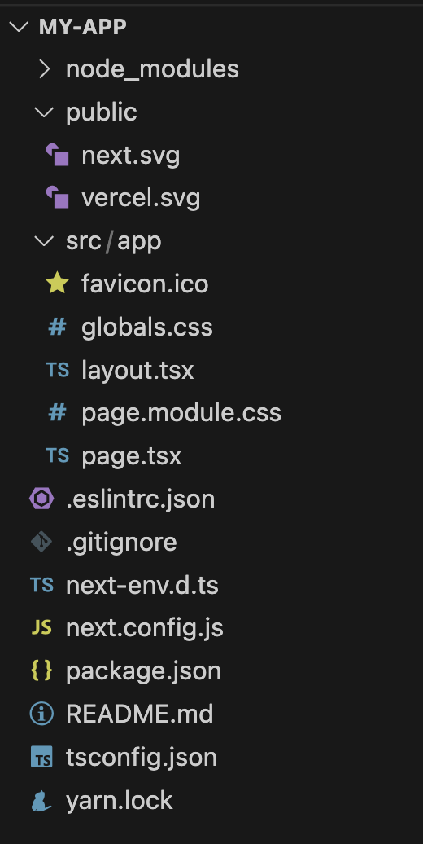

We have already seen some of the generated files – *package.json*, *yarn.lock*, *tsconfig.json*, *.gitignore*, *.eslint.json* and *README.md*. We also know what is the purpose of the *node_modules* and the *public* directories. We explained that in the **Create React App** section.

Let’s explore the new things here:

* *next.config.js*

This is the configuration file for Next.js. You can find all options [here](https://nextjs.org/docs/pages/api-reference/next-config-js).

* *next-env.d.ts*

The TypeScript declaration file for Next.js. This file ensures Next.js types are picked up by the TypeScript compiler. You cannot remove it, however, you can edit it (but you don't need to).

* *src* directory

This is an optional application source folder. A good practice is to create a *components* directory inside it, where your custom components will live. The nested *app* directory is important for us now. It is the [App Router](https://nextjs.org/docs/app) of our application. The components inside this directory are called [Server Components](https://nextjs.org/docs/app/building-your-application/rendering/server-components). These components allow us to write UI that can be rendered (and optionally cached) on the server. We won’t cover server-side-rendering (SSR) in this training path, but keep in mind that this is a powerful technique that improves our applications. You can read more about how Next.js renders components [here](https://nextjs.org/docs/pages/building-your-application/rendering).

Next.js uses a filesystem based router, where:

* Folders are used to define routes. Each folder represents a route segment, and each route segment is mapped to corresponding segment in a URL path.
* Files are used to create UI that is shown for a route segment.



URL path





Root segment

Segment

Leaf segment (dynamic)

As you can see in the scheme above, to create the routing for our Courses application (check the **React Router DOM** section), in the *app* directory we need to add a nested *courses* directory. The files inside are going to be used when users are on **/courses**. For our dynamic route, the one that displays individual course **/courses/[id]**, we need a nested directory inside the *courses* directory. There is a special syntax for dynamic segments – the folder’s name should be wrapped in square brackets. So, earlier we named our parameter as *id*, then the folder’s name should be *[id]*. You can find more information about dynamic routes [here](https://nextjs.org/docs/app/building-your-application/routing/dynamic-routes).

Let’s talk about the different files we can have inside each of these folders. There is a special file convention and hierarchy:

* *layout.tsx*

This file has the highest priority and having a root layout.tsx file is required. It includes the shared UI for a segment and its children.

* *error.tsx*

A custom error UI for a segment and its children. This file is optional.

* *loading.tsx*

Includes the loading UI for a segment and its children. Another optional file.

* *not-found.tsx*

A Not found UI for a segment and its children. Again, the file is optional.

* *page.tsx* or nested *layout.tsx*

This file has the lowest priority, is for the unique UI of a route. It also makes the route publicly accessible.

In a nested route, the components of a segment will be nested inside the components of its parent segment.



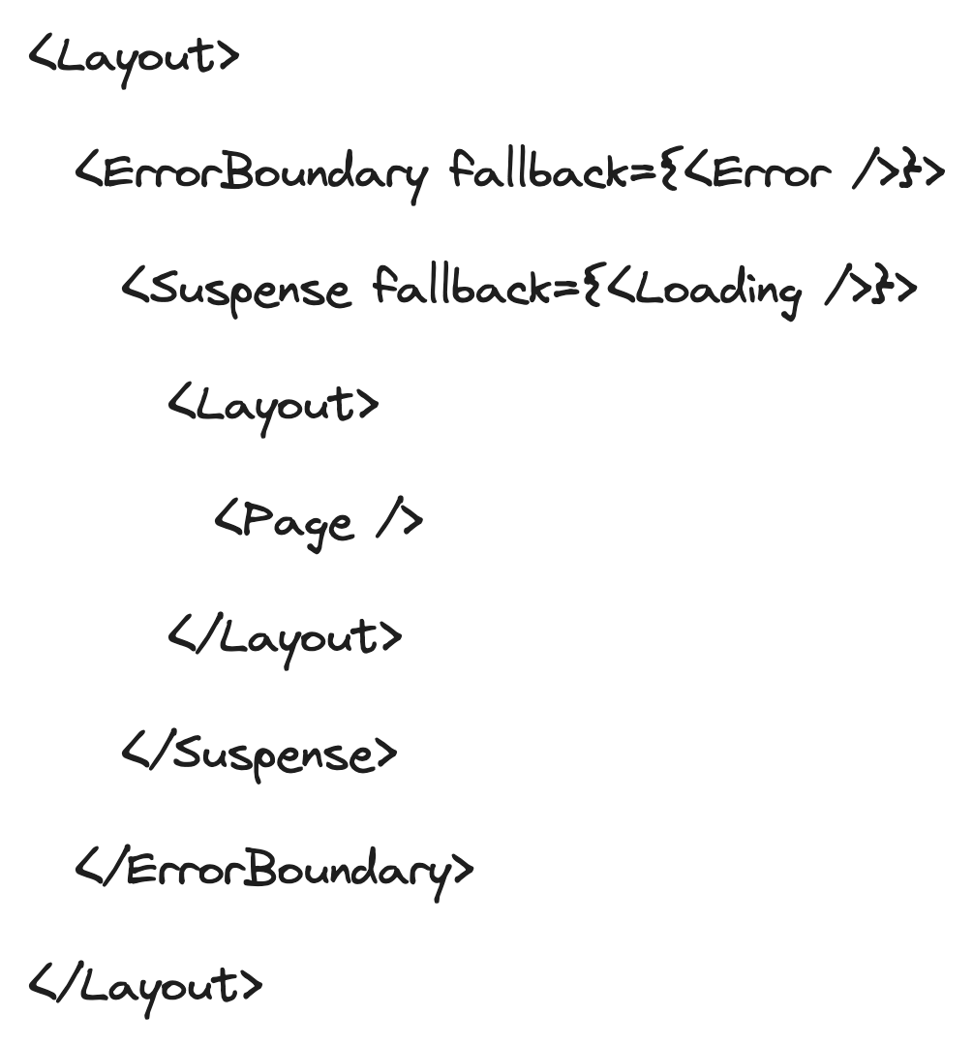













You can find more information about the conventions and the hierarchy [here](https://nextjs.org/docs/app/building-your-application/routing#file-conventions) and [here](https://nextjs.org/docs/app/building-your-application/routing#component-hierarchy) respectively.

Now, knowing all this, let’s try to use these files in our Courses project *(demo* [*53-routing-with-nextjs*](https://github.com/mayyamark/react-training-path/tree/master/53-routing-with-nextjs)*)*. For simplicity, we won’t use the optional *error.tsx* and *loading.tsx* files.

First, let’s refactor the root *layout.tsx* file. We don’t care about styles yet, so we can delete the [inter instance](https://fonts.google.com/specimen/Inter?vfquery=inter) (a font style). We have an exported *metadata* object that includes, e.g., the *title* and the *description* of the page. We can modify that if we want. Now, if you remember from the previous section (**React Router DOM**section), we want each page to display the navigation, so let’s modify the component. As mentioned [here](https://nextjs.org/docs/app/building-your-application/routing/pages-and-layouts#root-layout-required), the root *layout.tsx* must define *html* and *body* tags, since Next.js doesn’t create them for us, so we need to keep them. Inside the body tag, we can copy and paste everything from the previous section. Two things to change – instead of the *Outlet* component, here we simply use the *children* prop; the [Next.js Link](https://nextjs.org/docs/app/api-reference/components/link) component is a bit different, so change the *to* prop to *href*. At the end, this is how our root layout looks:



The next step is refactoring our root *page.tsx* file. If you remember, this is the UI that will be displayed when users are on **/**, in other words our home page. Let’s copy the *Home* component from the previous section and paste it here. That is it.



Now, if you click on the “Nothing here” link, you will see that there is a default 404 page. In our case, we want a custom one, as mentioned above, for that we need to add a *not-found.tsx* file.



Next, we need to implement the *layout.tsx* in the *courses* directory. This component would be our wrapper for the **/courses** route. We can use the *Courses* component from earlier, but instead of the Outlet component, we need the children prop.



The next step is implementing the *page.tsx* in the *courses* directory, so that we will display the list of courses when users are on **/courses**. Let’s copy that *CoursesIndex* from earlier. We need to fix two things in the Link components. We know the first one – we need to replace the *to* prop with *href*.



Finally, we need our *page.tsx* in the nested *[id]* directory (*src/app/courses/[id]*). Here we need the *id* from the URL and to render it in the heading. How can we get it? With a Next.js hook maybe? As previously mentioned, the components in the *app* directory are special ones, that are rendered on the server and hooks can be used on the client only. The Next.js page-components accept a *params* prop, from where we can read our *id*. Unfortunately, currently (October 2023), there are no Next.js typings for this prop, so we need to add it manually, as shown [here](https://nextjs.org/docs/app/api-reference/file-conventions/page). Also, we need to fix the *Link* component by replacing the *to* prop with *href*.



And this is it! We have created our Courses application, using Next.js. Again, we demonstrated only how routing works here. Keep in mind that this is a very powerful full-stack framework, and you might want to read the [official documentation](https://nextjs.org/) to learn more about it.

# An Example of a small project

In the repository, the last demo is [*54-gifest*](https://github.com/mayyamark/react-training-path/tree/master/gifest). This is a small application, bootstrapped with [Create React App](https://create-react-app.dev/), for viewing and uploading gifs with the following pages and functionalities:

* A page with infinite scroll, that displays trending gifs
  + Each gif could be liked by double-clicking on it
  + Hovering an individual gif, displays its details
* A header with search fild, that allows users to search gifs by keyword from any page
* A page, that diplays all liked gifs
* A page for uploading a gif
* A page, that displays all uploaded gifs

The application consumes the [Giphy API](https://developers.giphy.com/docs/api/).

Okay. Let’s take a look at the project itself. The first thing to do, when you see a project for the very first time, is to open the [*README*.*md*](https://github.com/mayyamark/react-training-path/blob/master/54-gifest/README.md). Usually, this is the place where we can find some basic description, setup guide, etc. In this case, the key note is how to run the application – we need to generate a [Giphy API key](https://developers.giphy.com/dashboard/?create=true) and add it as an environment variable.

The next step is reviewing the [*package*.*json*](https://github.com/mayyamark/react-training-path/blob/master/54-gifest/package.json) file, where we can find the list of dependencies. Here, we have installed [Emotion](https://emotion.sh/docs/introduction) and [MUI 5](https://mui.com/) for the UI, [React Router DOM](https://reactrouter.com/en/main) for the routing, and of course – React, ReactDOM and TypeScript. Also, an important part is the *scripts* section, where we can find which is the command for srarting the application. In the case of Create React App, that is the [start](https://create-react-app.dev/docs/available-scripts#npm-start) command. Now, you can execute that command with **yarn start** (or **npm start**) and open [http://localhost:3000](http://localhost:3000/) to view Gifest in the browser. You can play around to see the functionalities. Here are the designs, that we were following:

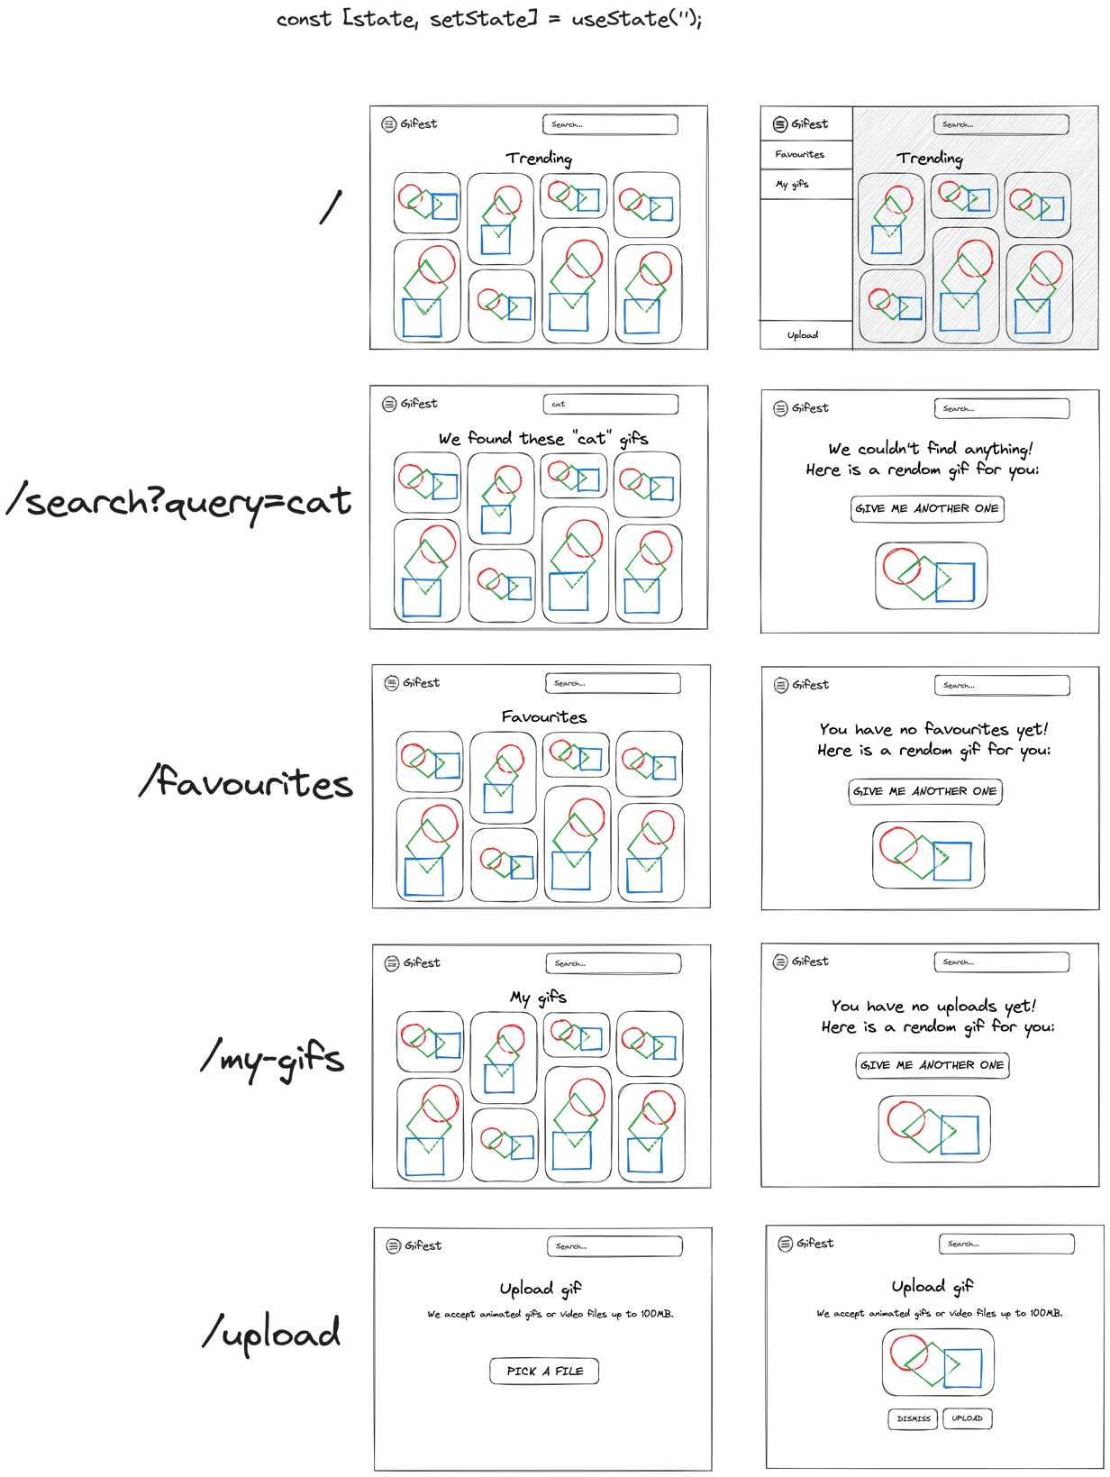

Now, let’s see the project structure and the implementation. We have two main directories – *public* and src.

The *public* directory is where the assets, in this case – the logo and the favicon, and the *index.html* file live. If you open the [*index.html*](https://github.com/mayyamark/react-training-path/blob/master/54-gifest/public/index.html), you can see a few custom things added. Did you notice the *style* attribute, attached to the *body* tag? By default some margins and paddings are added to that tag. In Gifest they are going to make the header a bit weird, so that’s one way to remove them.

Also, we can see that there is a child *style* tag. We use it to define a custom font family with the [@font-face](https://developer.mozilla.org/en-US/docs/Web/CSS/@font-face) rule.



The more interesting directory is the *src* one, where is our React logic. We have a [*types*.*ts*](https://github.com/mayyamark/react-training-path/blob/master/54-gifest/src/types.ts) file, which includes interfaces for our main data – gifs; of course, we also have an [*index.tsx*](https://github.com/mayyamark/react-training-path/blob/master/54-gifest/src/index.tsx) file – the entry point of our React application, and an [*App.tsx*](https://github.com/mayyamark/react-training-path/blob/master/54-gifest/src/App.tsx) – the main component.

Let’s take a look at the *App.tsx*. We have three state varaibles here:

* *query*

The variable stores the value of the input in the header. This value is used to filter gifs. The initial value is read from the current URL.

* *favourites*

This is an array of ids of all liked gifs. The initial value is read from [*localStorage*](https://developer.mozilla.org/en-US/docs/Web/API/Window/localStorage)*.* Why? Well, without *localStorage*, if we click the browser refresh button, the data for liked gifs would be lost.

* *uploads*

Similar to favourites, this is an array of ids, but of all uploaded gifs by the user. Again, the initial value is read from *localStorage*.

Next, we have two *useEffect*-s, the first one listens for changes in the *favourites* state and updates the stored data in *localStorage*, the second does the same, but for the *uploads* state.

Right after that we have two functions. The first one checks if the gif is liked, or not. The second function handles likes. If the passed id is in the *favourites* state, then remove the id, if not – add it.

And finally – the return. We have an *ErrorBoundary* (check the **Suspense & Error boundaries** section) and React Router DOM setup, which defines our routes (check the **Routing in React** section). If you look at the designs above, you will notice that all pages have identical layout – an app bar with a search field on the right and a logo with an icon on the left, which opens a menu with links to our pages. This is all we have in the *Layout* component, that the first [*Route*](https://reactrouter.com/en/main/route/route)renders. The nested *Route* components define our pages. The home page is where the trending gifs are displayed. Next is the search page, where we display all gifs, that are associated with the keyword, typed in the search field. The next two pages display the favourites and respectively, the uploaded gifs. Did you notice that the designs for these pages are similar? Yes, we reuse a single component for all of them. For the “Favourites” and “My gifs” pages, we have a case, where the *localStorage* is empty, so based on that, we render another component, that displays a random gif. The next page is the “Upload” one, which has a custom UI. The last route is the wildcard one. It displays a random gif again. And this is it!

In the *src* directory we have two nested directories. Let’s take a look at the [*hooks*](https://github.com/mayyamark/react-training-path/blob/master/54-gifest/src/hooks) one. As the name suggests, we have custom hooks here.

The [*useGetData*](https://github.com/mayyamark/react-training-path/blob/master/54-gifest/src/hooks/useGetData/useGetData.tsx) hook does a few things for us – [fetches](https://github.com/mayyamark/react-training-path/blob/master/54-gifest/src/hooks/useGetData/useGetData.tsx#L57) and stores the gifs data, tracks whenever the request is loading or failing and [handles the infinite scroll](https://github.com/mayyamark/react-training-path/blob/master/54-gifest/src/hooks/useGetData/useGetData.tsx#L47) by [attaching a scroll event to the window object](https://github.com/mayyamark/react-training-path/blob/master/54-gifest/src/hooks/useGetData/useGetData.tsx#L62).

The [*useUploadData*](https://github.com/mayyamark/react-training-path/blob/master/54-gifest/src/hooks/useUploadData/useUploadData.tsx)hook is similar, but it only sends the gif and tracks the request – if it’s loading, failing or succeeding.

Let’s move to the [*components*](https://github.com/mayyamark/react-training-path/tree/master/54-gifest/src/components) directory. As mentioned in the *README.md* file, the project follows the [Atomic Design Methodology](https://atomicdesign.bradfrost.com/chapter-2/), where:

* atoms – basic building blocks (e.g., button)
* molecules – 2 or more atoms together (e.g., drawer menu with links)
* organisms – 2 or more molecules together (e.g., whole page)

Take a look at the components, debug them, try to add some logic… Where to start from? My personal suggestion is to start from the *organisms*, the pages components. We saw them once in the *App* component, so it would be easier for you to see what happens in the large components first, and then to debug the smaller components.

Here is an example – open the [*GifsPage*](https://github.com/mayyamark/react-training-path/blob/master/54-gifest/src/components/organisms/GifsPage/GifsPage.tsx) component, which is used for most of our pages. Inside it, we can see that we call the custom *useGetData* hook and pass to it two of the props – *endpoint* and the *infiniteScroll* flag. As mentioned above, the hook returns the gifs *data* and the *loading* and *error* flags. If there is an error – the *GifsPage* component returns [*ErrorMessage*](https://github.com/mayyamark/react-training-path/blob/master/54-gifest/src/components/atoms/ErrorMessage/ErrorMessage.tsx)*.* What is that component? It’s one of our *atoms*, a single [*Typography*](https://github.com/mayyamark/react-training-path/blob/master/54-gifest/src/components/atoms/Typography/Typography.tsx)component, that displays the “An error occurred!” text. This *Typography* is a separate *atom,* which is just the [MUI’s *Typography*](https://mui.com/material-ui/customization/typography/) with some additional styles.

Now, if we go back to the *GifsPage* component, we can see that while we are waiting for the request to finish (*loading* is *true*), we render the [*Loader*](https://github.com/mayyamark/react-training-path/blob/master/54-gifest/src/components/atoms/Loader/Loader.tsx) atom – [MUI’s *CircularProgress*](https://mui.com/material-ui/api/circular-progress/)*,* wrapped in [MUI’s *Box*](https://mui.com/material-ui/react-box/) component.

Finally, in *GifsPage* we display the data in [*Masonry*](https://github.com/mayyamark/react-training-path/blob/master/54-gifest/src/components/atoms/Masonry/Masonry.tsx) (another *atom,* which uses [MUI’s *Masonry*](https://mui.com/material-ui/react-masonry/)) and each item is rendered with the [*Gif*](https://github.com/mayyamark/react-training-path/blob/master/54-gifest/src/components/molecules/Gif/Gif.tsx) component. This is a *molecule* component, that just displays the gif image ([*Image*](https://github.com/mayyamark/react-training-path/blob/master/54-gifest/src/components/molecules/Gif/Gif.tsx#L35) component). All other components in this file are created to implement the UI that appears, when you hover on the gif. Did you notice that? When you hover on each gif, two containers appear. The top one displays the title of the gif and some information for the user, that have uploaded it. The bottom one displays an favourite icon – a red one if the gif is liked, and a white, outlined one if the gif is not liked; and the [*SocialMediaShare*](https://github.com/mayyamark/react-training-path/blob/master/54-gifest/src/components/molecules/SocialMediaShare/SocialMediaShare.tsx) component, another *molecule*, that renders four link icons for sharing the gif in social medias.

We covered most of the components, just by reviewing one of the *organisms*. That was easy to follow, wasn’t it? Now try to do the same with the [*UploadPage*](https://github.com/mayyamark/react-training-path/blob/master/54-gifest/src/components/organisms/UploadPage/UploadPage.tsx) and [*NothingFoundPage*](https://github.com/mayyamark/react-training-path/blob/master/54-gifest/src/components/organisms/NothingFoundPage/NothingFoundPage.tsx)…

If any questions pop up, do not hesitate on asking [me](http://mayya.markova@accedia.com) or anyone in the [Front-end chat in Teams](https://teams.microsoft.com/l/channel/19%3A0e3a2d8a37704fc6bacca8836b916e1b%40thread.skype/Front-end?groupId=8db36f7d-d301-4ac1-932f-d05035a80bdb&tenantId=ddb1dc1a-50e3-4880-aa2e-dd26b62d9cbf).

# Build your own project

Congrats! You made it to the end of this training path! You have learnt a lot here and now it’s time to create your own project. Here are some ideas:

## Weather App

A weather app is a great React project for beginners, as it involves fetching and displaying data from an API. You can use the [OpenWeatherMap API](https://openweathermap.org/api?ref=altcademy.com) to get the weather data for a specific location. Your app should display the current weather, temperature, and weather forecast for the next few days.

## Cookbook App

A cookbook app would allow users to search for recipes based on ingredients, dish name, or cuisine. You can use the [Spoonacular API](https://spoonacular.com/food-api) to fetch the recipe data. Your app should display a list of recipes with images, titles, and short descriptions, and allow users to click on a recipe to view more details like ingredients, instructions and nutrition.

## Movies App

If you love watching movies, you can create an application for searching movies. You can use the [Movie Database API](https://developer.themoviedb.org/docs) to fetch the data. Your app should allow users to search for movies by title, director, or genre, and display a list of movies with images, titles, and short descriptions. Users should also be able to click on a movie to view more details like the cast, release date, and ratings.

## E-commerce App

An e-commerce app is a more complex project that allows users to browse products, add them to a shopping cart, and complete the checkout process. Try to implement storing the cart in localStorage. You can use the [Fake Store API](https://fakestoreapi.com/docs) to get the data.

## Social Media App

A social media app is a more advanced project that allows users to create an account, post messages, and interact with other users. You can use the official [SignalR package](https://www.npmjs.com/package/@microsoft/signalr) to create the web sockets.

## Quiz App

A quiz app allows users to take multiple-choice quizzes on various topics. You can use the [Open Trivia API](https://opentdb.com/api_config.php?ref=altcademy.com) to fetch quiz questions. Your app should display the quiz questions one at a time, with the user selecting an answer before moving on to the next question. At the end of the quiz, the user should see their score and have the option to retake the quiz.

## Job Board App

A job board app allows users to search and apply for jobs. You can use the [Job Board API](https://developers.greenhouse.io/job-board.html), to fetch job data. Your app should allow users to search for jobs by keyword and display a list of jobs with titles, companies, short descriptions, etc. Users should also be able to click on a job to view more details and apply for the job.

Finally, here is a list of important things. Think about them, while coding:

* Create a good project structure.
* Don’t forget to pick descriptive names for your components and methods.
* Don’t overuse memoizations and context.
* Use routing – all real projects have different pages.
* Add some styles – unfortunately or not, frontend developers spend a lot of the time in styling.